Scoil Chéile Chríost Rathmore N.S. Newsletter Seven. 2025/2026

Welcome to our latest Scoil Chéile Chríost, Rathmore NS newsletter! It has been a very busy and exciting time in our school, with lots of great learning, fun activities and fantastic achievements. From Gaeilge and art to sports and STEAM, our pupils have been working hard and showing great teamwork and school spirit. We hope you enjoy reading about all the wonderful things happening in our school!

Attendance Hero.
This month saw the start of our Attendance Drive. Our aim is to Help Every Child Make the Most of Every School Day.
Research shows that regular attendance not only supports children’s learning, but confidence and wellbeing. We encourage all pupils to be Attendance HEROes:
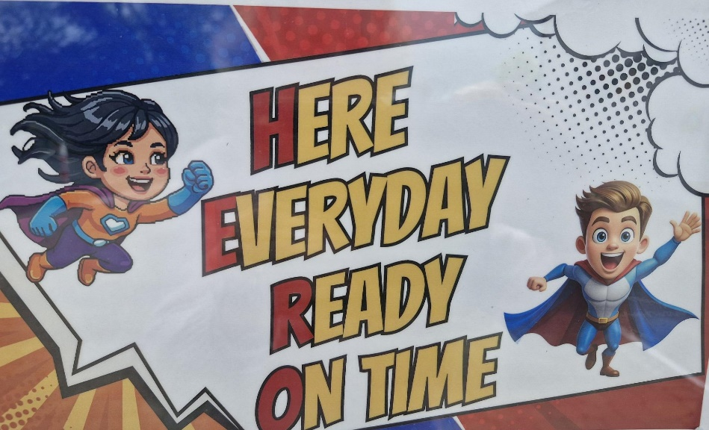
For the next two months of May and June we have planned individual and class incentives
- Monthly class rewards (Pizza/PE Party for the best class & Breakfast Bonus for the most improved class)
- Weekly raffle for pupils with full attendance
Attendance HERO posters and Student Council visits will help promote the message. We take a supportive approach to attendance and will work with families where needed. Thank you for helping your child be an Attendance HERO!

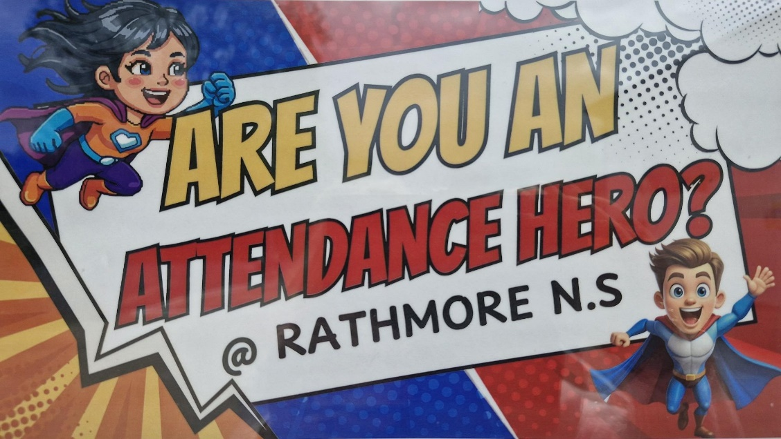

Acceptable Use Policy (AUP)
Our school is committed to promoting the safe and responsible use of digital technology by all pupils. Our Acceptable Use Policy (AUP) outlines the expectations for students when using digital devices, the internet, and online tools, both within school and at home.
We are delighted that our Student Council, in collaboration with Ms. Behan, is currently developing a child-friendly version of the AUP. This initiative ensures that pupils better understand their responsibilities in a way that is accessible and meaningful to them.
We are also proud to be one of a number of the schools in the Naas area participating in the “Go Phone Free” Initiative, which promotes healthy digital habits and reduced reliance on mobile phones among children.
To support this work, we will host an Acceptable Use Awareness Week. While digital safety is reinforced throughout the year, this dedicated week will coincide with the launch and promotion of the child-friendly AUP, helping to further raise awareness among pupils.
We ask all parents and guardians to support this work by:
- Carefully monitoring their child’s online and social media activity
- Regularly checking devices, apps, and browsing history
- Being aware of group chats and online interactions
We are aware that, at times, group chats can become a space where unkind or inappropriate comments are shared. It is important to remember that parents have a key responsibility in supervising their children’s online activity outside of school.
There are many helpful resources available to support parents in this area. We recommend visiting Webwise (www.webwise.ie), which offers practical advice and guidance on keeping children safe online.
By working together, we can ensure that all children develop the skills and awareness needed to use technology safely, respectfully, and responsibly.

Seachtain na Gaeilge Winners.
The winners of this year’s Gaeilgeoirí na Seachtaine have done an amazing job and should be very proud of themselves! Over the course of Seachtain na Gaeilge, they made a fantastic effort to speak Gaeilge as much as they could, both in class and around the school. They didn’t just use it when they had to—they looked for every chance to practise, whether chatting with friends, answering questions, or even trying out new words and phrases. That takes real confidence and bravery!
They showed us all how fun and important it is to use our native language every day. Gaeilge is a special part of our culture, and by speaking it, they are helping to keep it alive and strong. Their hard work, positive attitude, and willingness to give it a go have set a brilliant example for everyone else. Well done to all of you—you are true Gaeilgeoirí!
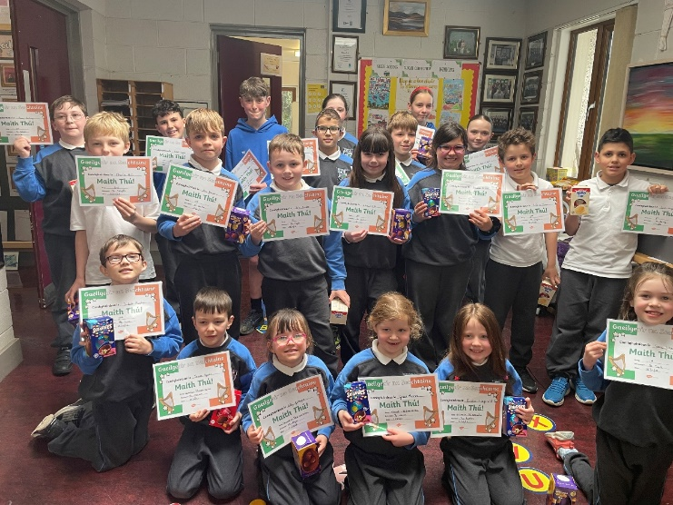

Comórtas Ealaíne
Congratulations to all the winners of our Seachtain na Gaeilge art competition—what a fantastic display of creativity and effort! Our Junior artists did a brilliant job bringing their leprechaun pictures to life, using bright colours and careful colouring to make each piece unique and full of fun. Meanwhile, our Senior entrants impressed us with their thoughtful and beautifully designed seanfhocal posters. A seanfhocal is a traditional Irish saying or proverb, often passed down through generations, that shares wisdom or a life lesson in just a few words. The way the students illustrated these sayings showed great imagination and a real understanding of their meaning. Well done to everyone who took part—your hard work and talent truly shone through!
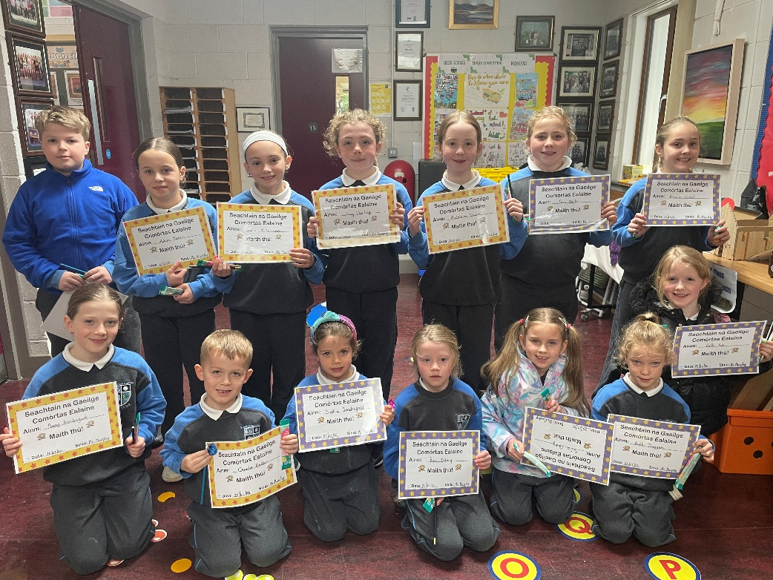
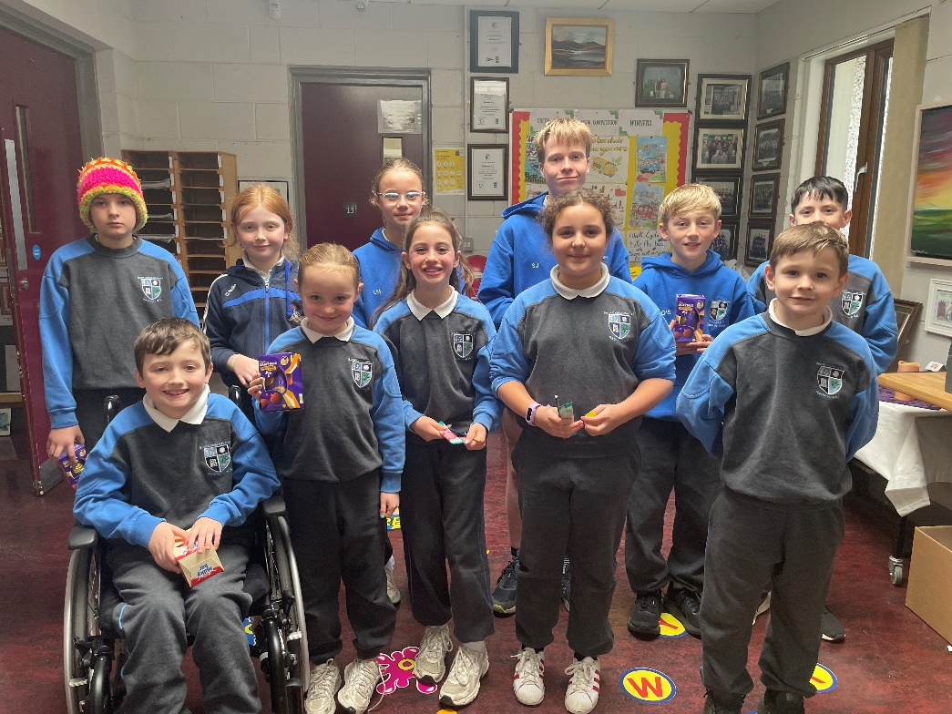

Climate Literacy Programme
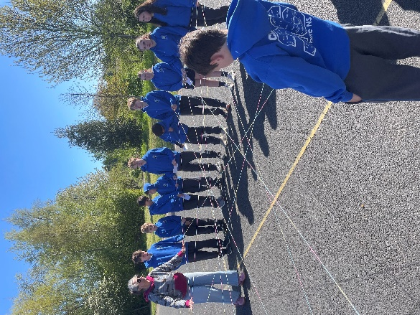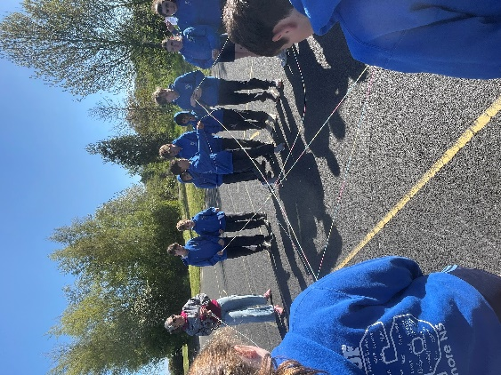
The children in Mr Bolton’s 6th Class have begun taking part in an 8-week Climate Literacy Programme, delivered by Sanja Dunne from Education for Sustainability. The programme takes place each Wednesday and aims to build the students’ understanding of climate change and empower them to take positive action.
Throughout the programme, the children will explore topics such as the science behind climate change, the impact of human activity on the environment, and the importance of biodiversity. They will also learn about sustainability, renewable energy, and practical steps they can take in their everyday lives to help protect the planet. The lessons are interactive and encourage discussion, critical thinking, and teamwork.
The children have really engaged with these important topics over the first few weeks and love having Sanja in the classroom.

First Holy Communion.
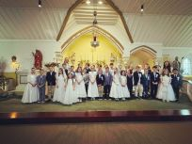

Congratulations to the children in Ms. Smyth and Ms. Lyne’s Second Classes who received the Sacrament of First Holy Communion in the Church of the Immaculate Conception, Eadestown on Saturday 16th May with Mass celebrated by Fr. Micheál Comer. It was a very special day filled with joy and excitement for the children and their families. The pupils looked wonderful and took part beautifully in the ceremony, showing great respect and enthusiasm throughout. Many thanks to Ms. Larkin for the musical accompaniment and for preparing the school Choir who sang beautifully, to our school Secretary Martina Lawler for preparing the Communion Mass Booklet and to our caretaker Paul O’Sullivan for his assistance with the transport and display of the children’s Art in the Church. Thank you also to the Parish Pastoral Committee for their preparatory work with the children in partnership with the school. We are very appreciative of our Parents Association and group of parent volunteers who organised the Communion Reception in Rathmore Community Hall after the Mass for all the children and their families which was very much appreciated. Thank you to all the parents/guardians who generously donated home baking. We hope that everybody had a very happy family day of celebration in our community.

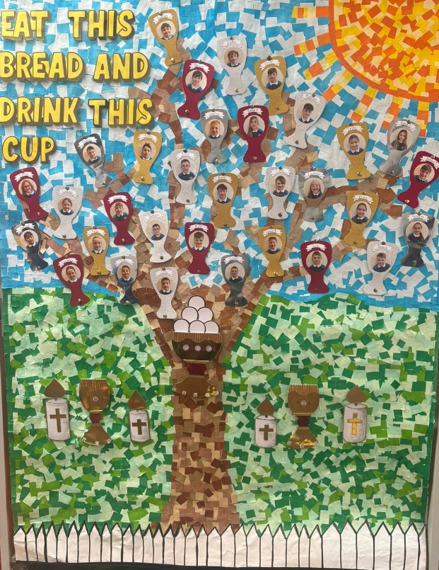

School Lunches.
Survey feedback from both pupils and parents indicates a clear preference for cold lunch options over hot meals. Despite a high uptake of the hot lunch scheme, a significant number of meals are going uneaten, with many parents continuing to provide lunches from home.
The Student Council consulted pupils, while the Parents’ Association gathered feedback through parent groups, and both sets of findings were closely aligned. Considering this, and with the tender up for renewal, the Board of Management decided to proceed with a tender for a cold lunch provision.
Unfortunately, the Department does not currently allow for a blended or seasonal model. The tendering process is now nearing completion, and parents will be informed shortly about the provider and available options for the coming school year.


Parents Association Uniform Swap Initiative
The Parents’ Association is currently organising their annual Uniform Swap. To allow time for uniforms to be washed and sorted, the final week of term will be a non-uniform week.
Donations of clean, good-quality uniforms can be dropped to the PE hall in school on the afternoon of Tuesday 23rd. The Uniform Swap will then take place the following day in the PE Hall on Wednesday 24th.
This is a fantastic initiative that promotes sustainability and supports families by allowing uniforms in good condition to be reused by younger children in the school.
There is always a strong demand for items such as grey trousers, skirts, shirts, and V-neck grey jumpers, particularly from families of Sixth Class pupils who are the youngest in their household.

Our lost and found box is overflowing. Please come in and check if you are missing items of school clothing.

SPOTLIGHT ON STEAM: PUPIL VOICE
This month, 5th Class and Senior Infants teamed up for a fun and engaging outdoor learning activity using iPads and the Book Creator app. We explored the school yard and track together, searching for repeating patterns in our environment.
The children worked in small groups to observe, record, and document their findings. Jamie and Éala discovered a red and white repeating pattern in the chain around the yard. Cian and Thea spotted a black and white pattern on the chess board. Louie and Donnacha found an interesting diagonal pattern on a sewer gate. Hannah and Tessa identified a 1-square, 2-square pattern in the hopscotch markings, while Bobby and Susie noticed repeating blue and white dots on an outdoor game board.
It was a wonderful opportunity for collaboration between classes, combining technology with hands-on exploration. The pupils thoroughly enjoyed capturing their discoveries and adding to their Book Creator class book.
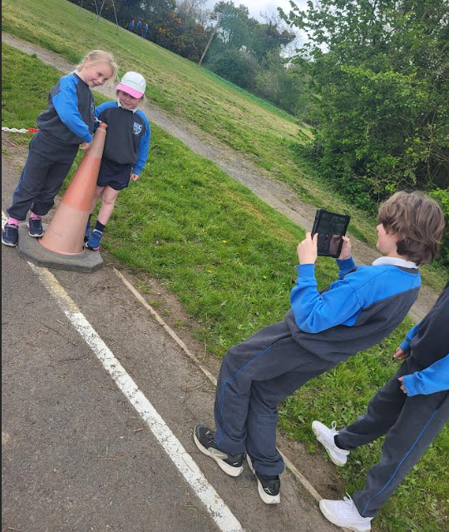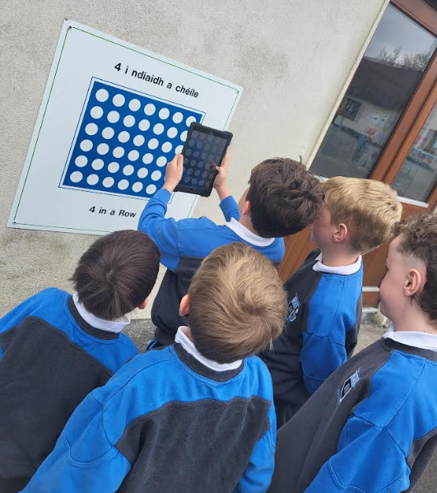

Cumann na mBunscol Cross Country Championship 2026
Sixteen boys and fifteen girls from 4th, 5th and 6th Class proudly represented Rathmore NS at the Cumann na mBunscol Cross Country Championships held in Rathcoffey on March 26th. The pupils had been training hard in the weeks leading up to the event under the guidance of their mentor, Ms. Malone, and their hard work and commitment truly paid off on the day. The Boys’ Team A delivered an outstanding performance, securing 1st place and bringing the trophy back to Rathmore for the second year in a row. The Girls’ Team A also achieved great success, finishing in 3rd place — a fantastic accomplishment in a very competitive field. There were impressive individual performances as well, with Senan (6th Class) winning a silver medal in 2nd place, Joe (6th) taking bronze in 3rd place in the boys’ race, and Zoe (4th Class) finishing an excellent 5th overall. It was a wonderful achievement for all involved and a proud day for Rathmore NS.

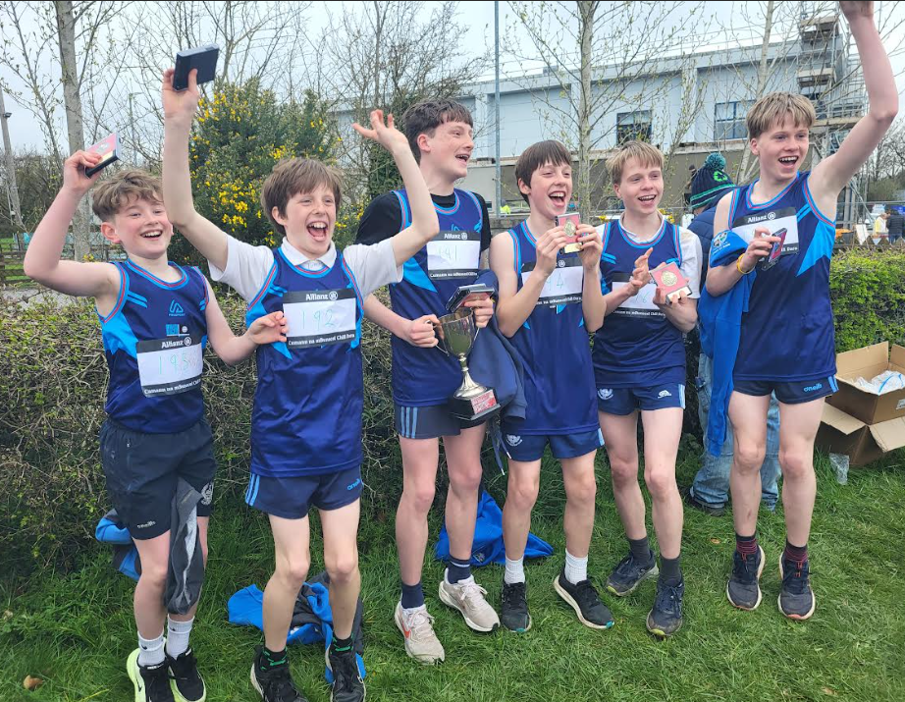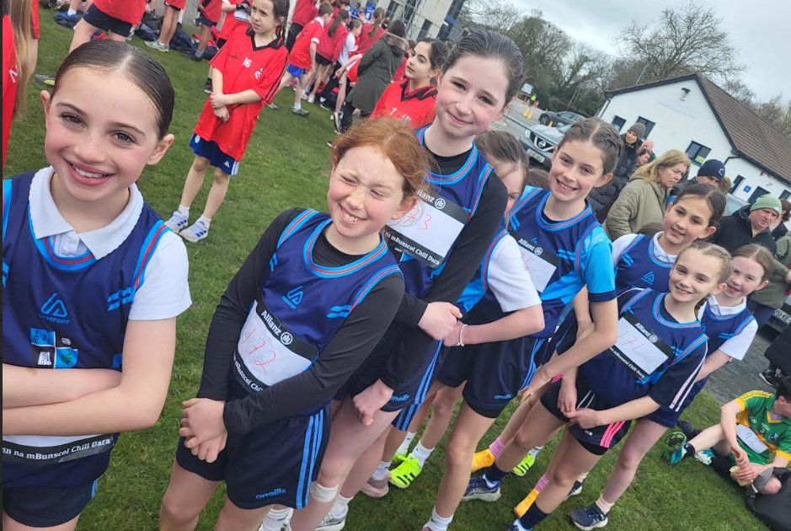

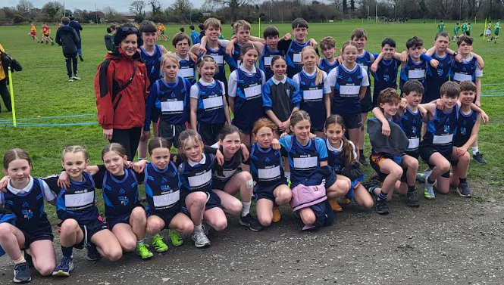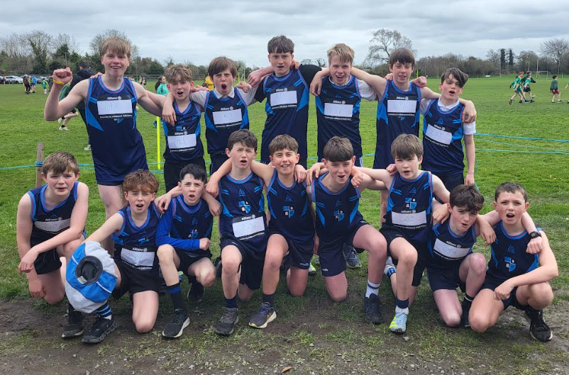
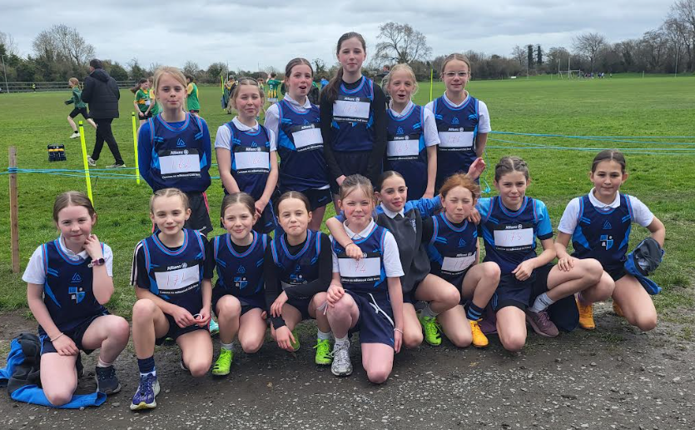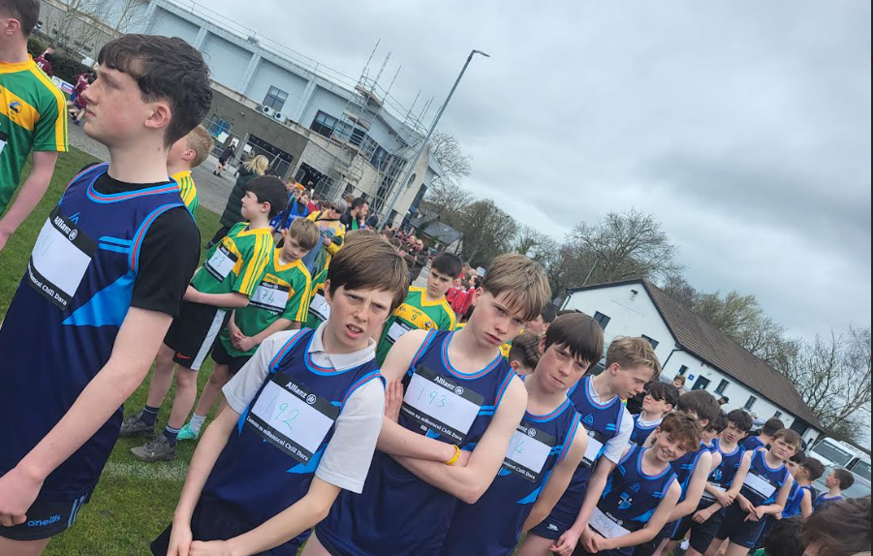
6th Class Cycle Right Programme
Our 6th Class pupils are currently taking part in the Cycle Right programme, the National Standard for Cycle Training in Ireland. This is an 8-hour practical course delivered over 5–6 weeks by fully qualified Active Ireland instructors.
Throughout the programme, pupils develop essential cycling skills, including safe road positioning, signalling, and awareness. Most importantly, they build confidence in their ability to cycle on the road. By the end of the course, all participants are equipped with the skills and knowledge needed to cycle safely and independently

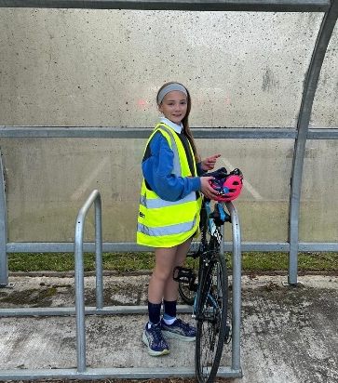

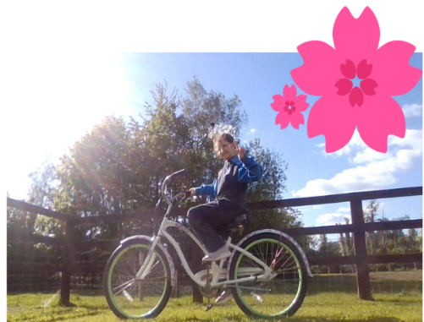
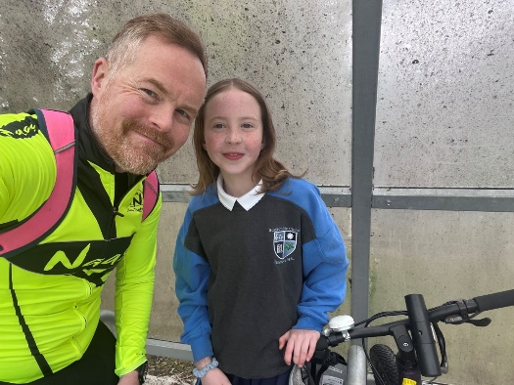
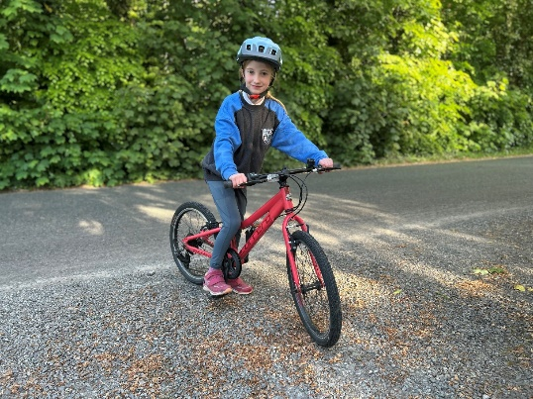

Bike Week!
Bike Week was a great success here at Rathmore NS! As part of our Green Schools activities, we assigned some “bike homework” and were delighted to see so many pupils getting involved by cycling with their families and practising their bike skills at home.
We received some fantastic photos from our students enjoying their bikes during the week. A special mention goes to Madeline Downes, Caitlin and Matthew O’Sullivan, they all cycled to school with their parents. What a brilliant way to start the school day!
Our 6th Class students have also started their Bike Safety Workshops, where they are learning important cycling skills and road safety awareness. We look forward to seeing all they learn over the coming weeks.
A huge thank you to all the parents and children who got involved and supported Bike Week. Your enthusiasm helped make the week such a positive and active event for everyone.
The Green Schools Committee
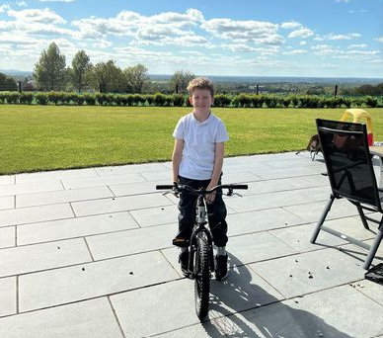

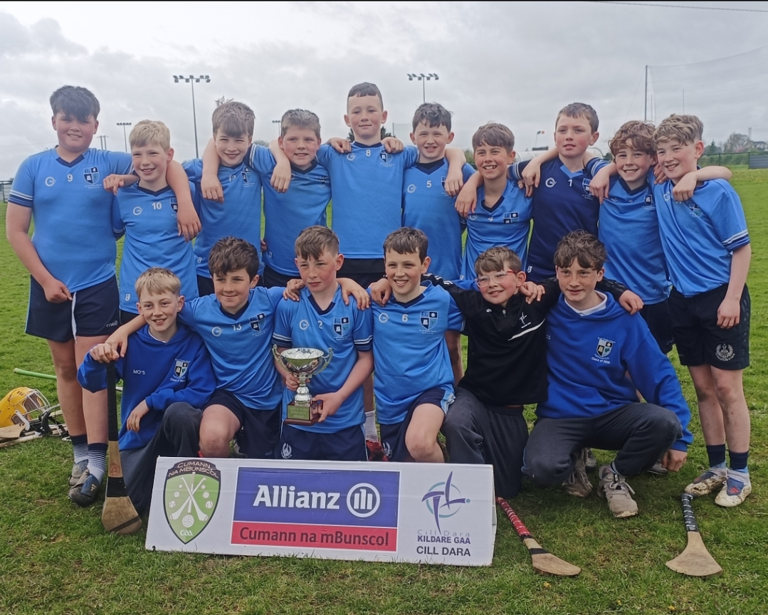
Rathmore NS Boys Win Back-to-Back Kildare Mini 7’s Hurling Titles
The Rathmore NS boys’ hurling team secured an historic back-to-back victory in the Kildare Mini 7’s Hurling Tournament on Thursday, April 16th. After topping their group in the qualifying rounds held at Naas GAA two weeks earlier, the team progressed to the finals at Hawkfield GAA grounds.
Rathmore faced a strong St Corban’s team from Naas in their opening match. Despite playing excellent hurling and leading in the closing stages, two late goals saw St Corban’s claim a narrow two-point win.
The Rathmore boys responded impressively in Round 2 against Ardclough NS. After an early Rathmore goal, Ardclough fought back and led heading into the final minutes. However, Rathmore showed great determination and teamwork, scoring a crucial late goal to secure victory.
Confidence continued to build as Rathmore delivered a dominant performance against Gaelscoil Uí Fhiaich, setting up a decisive final round. With St Corban’s facing Ardclough NS, Rathmore knew a win against St Brigid’s NS would be enough to retain their title. They rose to the occasion, producing their best performance of the day with skilful, free-flowing hurling from start to finish.
At the final whistle, Rathmore NS were crowned champions once again, proudly bringing the trophy back to the school for the second year in a row.
Rathmore NS Team: Sam Berrigan, Jack Ryan, Charlie Ashe, Donagh O’ Sullivan, Sam Guinan, Bobby Early, Cian Butler, Caolan Kim, Daithí Butler, Will Dermody, Alex Readman, Danny Graham, Danny Fox.

Home–School Communication Reminder
To ensure clear and consistent communication between home and school, we kindly ask you to note the following:
- Teacher Microsoft accounts are used solely during periods of remote learning.
- All communication from the school to parents is sent via Aladdin.
- For day-to-day communication, parents can use the pupil diary or contact the school office by email.
Thank you for your cooperation in helping us maintain effective communication.
End of Year School Tours.

All classes are looking forward to going on an end of year School Tour. Information on each class tour will be communicated to parents/guardians by your child’s class teacher. Parental permission and online payments through Aladdin E-Payments.

Class Level | Date | Class Tour
Junior & Senior Infants | Friday 29th May | Kidspace Rathcoole
First Class | Monday 8th June | Let’s Go, Kilcullen
Second Class | Tuesday 16th June | Let’s Go Kilcullen
Third and Fourth Class | Monday 25th May | GO Quest Sandyford
Fifth and Sixth Class | Friday 12th June | Clara Lara

Upcoming Dates.
Open morning for Incoming Junior Infants and their parents, 9:15-10:45.
Information Meeting for Incoming Junior Infant Parents, Thursday 28th May 2pm-2:30pm to coincide with Incoming Junior Infants visit to Infant classrooms.
NOTE: Additional School Closure Primary Curriculum Framework Whole School CPD: Wednesday 27th May 2026
June Bank Holiday: School closed on Monday 1st June, Tuesday 2nd June and Wednesday 3rd June. School re-opens on Thursday 4th June 2026

Sixth Class Graduation Mass, on Friday 19th June at 11:00 am. Sixth Class parents welcome.

Drop off Uniforms for Uniform Swap on afternoon of Tuesday the 23rd of June.
Uniform Swap on Wednesday 24th June in PE Hall. Details to follow.

Summer holidays commence on Friday 26th June 2026 at 12.30pm.
School Reopens on Thursday 27th August 2026 at 9am.

