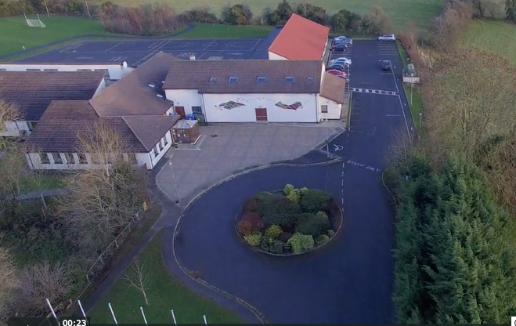
Scoil Chéile Chríost Rathmore NS
Rathmore, Naas, Co. Kildare. W91 VK46
Telephone: 045 862145
Roll Number: 01821v
Email: office@rathmorens.ie
Web: www.rathmorens.ie
Registered Charity Number: 20124151
Principal: Ms. Caitríona Lancaster
Deputy Principal: Mr. Shane Walsh

Remote Teaching and Learning Policy

Introduction
This Remote Teaching and Learning Policy outlines the procedures to ensure continuity of education at Scoil Chéile Chríost Rathmore N.S. when pupils must be educated off-site due to school closure or any circumstance preventing in-person teaching.
The purpose of this policy is to:
- Maintain strong and clear links between school and home
- Support ongoing teaching and learning through safe, secure digital platforms
- Protect staff and pupils through appropriate online-safety measures
- Ensure compliance with statutory obligations and data protection legislation
- This policy is an addition to, and must be read in conjunction with:
- Acceptable Use Policy
- Code of Behaviour
- Anti-Bullying (including Cyberbullying) Policy
- Data Protection and GDPR policies

Context
Advances in digital learning provide opportunities for teachers and pupils to collaborate remotely. Whether learning takes place in school or from home, all school rules and policies remain fully in effect. The Remote Teaching and Learning Policy operates in direct partnership with the school’s Acceptable Use Policy (AUP).

Scoil Chéile Chríost Rathmore N.S. uses secure, child-friendly platforms to ensure high-quality teaching and effective communication when remote learning is required.

Communication Procedures
Communication From School
- Aladdin is the school’s official communication platform.
- All announcements, updates, and teaching plans will be sent through Aladdin.
- Parents/guardians are expected to check the Aladdin app daily.

Teacher Communication with Parents
- Teachers will communicate with parents via their school-issued Microsoft Office 365 teacher email accounts only during periods of remote learning.
- Parents must use the email address registered on Aladdin.
- Queries will be addressed during school hours only (8:45am–2:30pm).

Parent Communication with the School
For all general communication unrelated to remote learning, parents should use:
- The pupil’s diary, or
- The school office email account
- Teacher Microsoft email accounts must not be used for routine daily communication outside periods of remote teaching.

Digital Platforms for Remote Teaching and Learning.
Scoil Chéile Chríost Rathmore N.S. uses the following digital tools when remote learning is required:

Aladdin
- Main platform for school communication and weekly learning plans.
- Teachers will post weekly assigned work (typically on Sundays).

Microsoft Office 365 Teacher Email Accounts
- Used exclusively for remote learning situations.
- Facilitates communication between teachers and parents regarding learning activities.

Seesaw
- Used by pupils from Junior Infants to Sixth Class.
- Allows pupils to access assigned activities, upload work, and view pre-recorded lessons.
- Requires parental consent and unique pupil access codes.
- All platform use must comply with the Acceptable Use Policy

Guidelines for Safe and Respectful Online Communication
Expectations for All Users
- All communication must be appropriate, respectful, and kind.
- Parents/guardians must supervise pupil activity online.
- Only school-approved platforms (Aladdin, Seesaw, teacher MS emails) may be used.
- Communications should relate only to educational purposes.
- Passwords must be always kept secure.
- The school cannot accept responsibility for external platform security breaches.
- Any breach of guidelines may result in access restrictions or removal from a digital session as set out in the AUP.

Protocols for Students
- Check weekly assigned work as directed.
- Submit work during school hours only; submissions outside hours will be reviewed the next working day.
- School calendar applies as normal.
- Relevant policies, including Code of Behaviour, Anti-Bullying, and Acceptable Use Policy, apply during remote learning.
- Students must complete and present work to the best of their ability.
- Where possible, support will be provided for students with additional learning needs.

Protocols for Parents/Guardians
- Ensure students follow the above protocols.
- Supervise online activity and check submissions for appropriateness.
- Encourage safe and responsible use of technology.
- Support learning while prioritising pupil wellbeing.
- Where time is limited, focus should be placed on:
- Daily reading
- Maths work as directed by the teacher
- Writing practice

Protocols for Teachers and SNAs
- Check and respond to uploaded work weekly.
- Communicate only during official school hours.
- Follow the standard school calendar.
- Adhere to Child Protection, Data Protection, and Acceptable Use Policies.
- Maintain high standards of teaching and learning.
- Teachers will include a weekly well-being check-in with pupils during periods of remote learning. This may take the form of age-appropriate activities, messages, or opportunities for pupils to share how they are feeling, to support emotional wellbeing and maintain connection with the school.

Use of Platforms During School Closure
In any situation requiring remote teaching, class teachers will use a combination of:
- Seesaw (assigned work, lesson materials, pupil submissions)
- Aladdin (updates, weekly plans)
- Microsoft teacher emails (remote-learning communication with parents)

Approaches may include:
- Pre-recorded lessons
- Assigned tasks and activities
- Feedback via Seesaw
- Regular updates and guidance through Aladdin
- No work will be assigned during planned school closures or holidays, and there will be no Seesaw interaction during these periods.

Summary
- Teacher Microsoft accounts are used only during remote learning periods.
- All communication from school to home is via Aladdin.
- Parents use the pupil diary or school office email for everyday communication.
- Families should stay connected to all platforms and seek support if difficulties arise.
- Learning should be balanced with pupil wellbeing.
- Pupil wellbeing remains a priority, and regular wellbeing check-ins will form part of remote teaching and learning.
- Parents, pupils, and teachers must follow all policies and procedures outlined.

Review
The policy is to be reviewed regularly or earlier if required due to legislation or organisational changes.
This Remote Teaching and Learning Policy was ratified in April 2026.

Signed: _____________________________ Date: ______________
Chairperson, Board of Management

Signed: _____________________________ Date: ______________
Principal

An original signed copy available in the School Office

