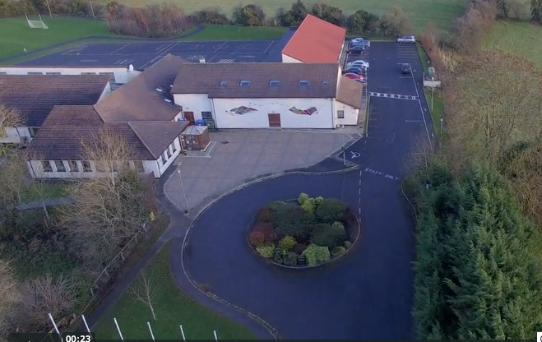
Scoil Chéile Chríost Rathmore NS
Rathmore, Naas, Co. Kildare. W91 VK46
Telephone: 045 862145
Roll Number: 01821v
Email: office@rathmorens.ie
Web: www.rathmorens.ie
Principal: Ms. Caitriona Lancaster
Deputy Principal: Shane Walsh

ANNUAL ADMISSION NOTICE.
In respect of admissions to the 2026/2027 School Year
Admission Policy and Application Form

A copy of the school’s Admission Policy and the Application Form for Admission for the 2026/2027 School year is available as follows: –
To download at: www.rathmorens.ie or on request by emailing office@rathmorens.ie or writing to: Scoil Chéile Chríost Rathmore N.S., Rathmore, Naas, Co. Kildare. W91 VK46.
This Admissions Policy should be read in conjunction with all School Policies (available on the School Website)

PART 1 - Admissions to the 2026/2027 School Year
Application and Decision Dates for admission to 2026/2027.
The following are the dates applicable for admission to Junior Infants.
The school will commence accepting applications for admission on | 05/01/2026
The school shall cease accepting applications for admission on | 06/02/2026
The date by which applicants will be notified of the decision on their application is | 13/02/2026
The period within which applicants must confirm acceptance of an offer of admission | 13/02/2026 to 20/02/2026
The date within which applicants must furnish a completed Enrolment Form | 27/02/2026

*Failure to accept an offer within the prescribed period above may result in the offer being withdrawn
Note: the school will consider and issue decisions on late applications in accordance with the school’s admission policy.

Number of places being made available in 2026/2027.
The number of places being made available in Junior Infants | 46

