Scoil Chéile Chríost Rathmore N.S. Newsletter Four. 2025/2026

Welcome to our final Newsletter of 2025.

What a magical month it has been! Each of our classes delighted us with their Christmas shows, performing for parents in Rathmore Community Hall that had been beautifully decorated. Thanks to the incredible efforts of our Parents’ Association, not only did the hall look great, but the stage was also wonderful, and the atmosphere was festive. It was a lovely opportunity for families to gather, relax, and enjoy watching their children shine.
Behind the scenes, our parents were as busy as Santa’s elves—organising raffle prizes, selling tickets, and ensuring everything ran smoothly. And, of course, Santa himself managed to make a flying visit, to everyone’s excitement! We were thrilled to welcome him.
On behalf of myself and all the staff, I want to express our heartfelt thanks for the ongoing help and support we receive—from helping in the garden each week and library every Friday and helping and supporting at sporting events. This does not go unnoticed, and we deeply appreciate it.
Finally, a huge well done to our wonderful children, who worked so hard all year, and performed so well in their shows Their enthusiasm was clear for all to see—there is no doubt they are all top of Santa’s nice list!
As we approach the holidays, on behalf of the school staff, I wish you and your families a Wonderful Christmas filled with peace, laughter, and making lovely memories together. May the New Year bring health, happiness, and continued success for all. Thank you —we look forward to another exciting year ahead.
Caitríona Lancaster.


School Mass – Feast of the Immaculate Conception 8th December 2025.
Fr. Micheál Comer celebrated mass in the school PE hall on Monday the 8th of December for the Feast of the Immaculate Conception at 11.30am and the children and their teachers from second class upwards and several parishioners joined us. The choir sang beautifully, led by Ms. Larkin who also provided the music.
We are now in the season of Advent and have begun our preparations to celebrate the birth of Jesus on Christmas Day.
Special thanks to Brigid Judge for making a beautiful Advent Wreath which is on display in the school lobby.
This Photo by Unknown Author is licensed under CC BY-NC-ND

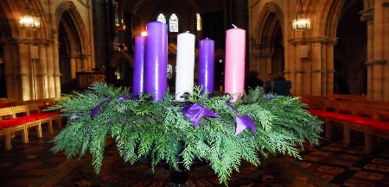

Christmas Concerts
Our Christmas concerts took place on Friday, 12th December in Rathmore Community Hall, where children from Junior Infants right through to 6th Class took to the stage. Huge work went into preparing these performances, and it truly showed on the day. The children were fantastic and thoroughly enjoyed displaying their talents. A massive thank you to our Parents’ Association for their invaluable support in making the event such a success. It was a wonderful occasion enjoyed by everyone in attendance.
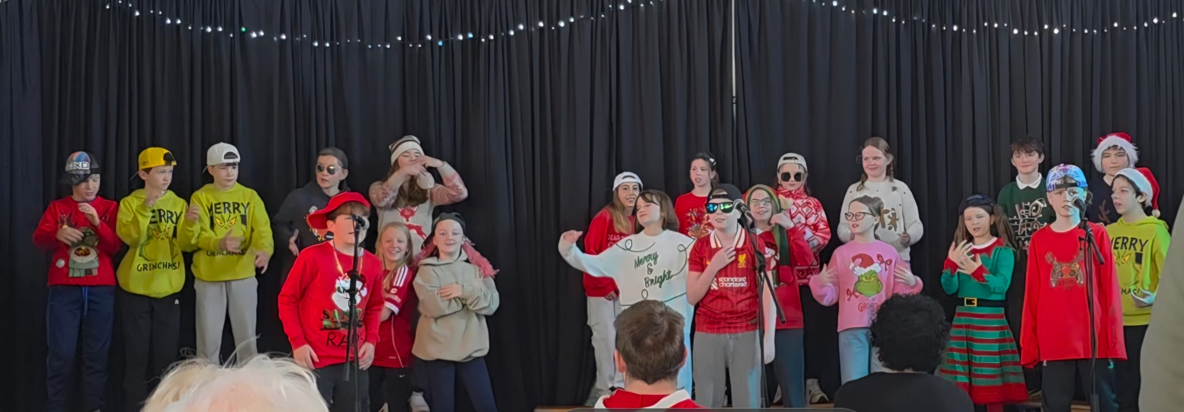
Ms. Malone’s Fifth Class performance.
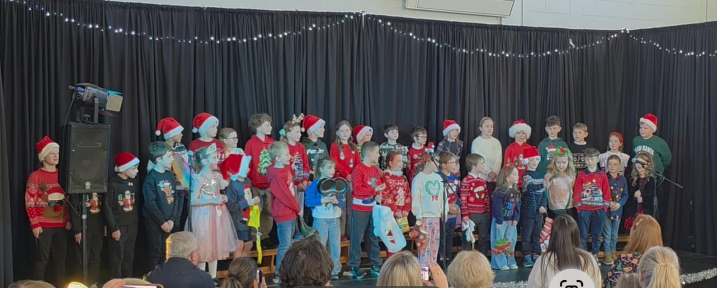
Ms. Kenny’s and Ms. Smith’s Second Classes Performance.
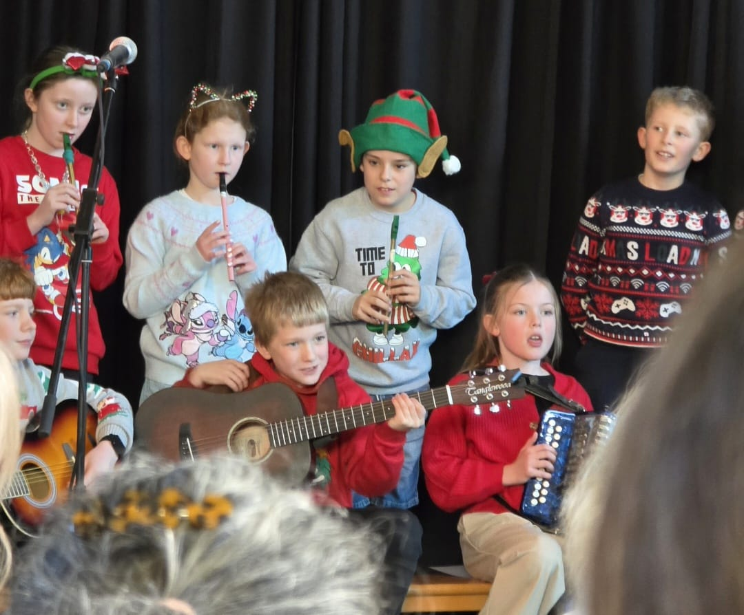
Ms. Murray’s Fourth-Class Performance.

Mary Ryan and Tin Whistles.
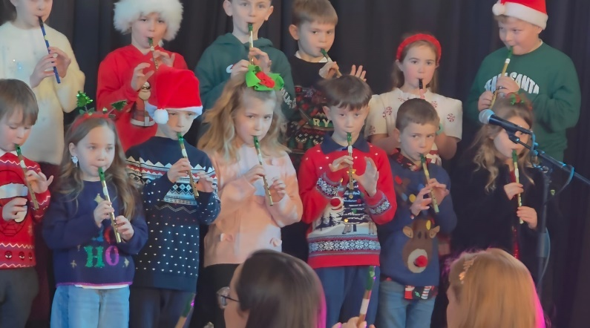
We are delighted that Mary Ryan of Kilteel Comhaltas has begun teaching the tin whistle to the children in Ms. Kenny and Ms. Smith’s Second Classes. The children are learning quickly from Mary and played beautifully at the Christmas Show.

Santa’s Visit.
On Tuesday, 16th December, we had a special surprise visitor! Dressed in his lovely red suit, he took time away from his busy schedule at the North Pole and the golf course, to visit our school, meeting the children from Juniors to Second for a chat and a quick visit to the classrooms from third to sixth! He shared lots of helpful advice with the children on how to climb even higher up the Good List—including going to bed early, eating their vegetables, brushing their teeth, and even joining the local Eadestown GAA Club!!!
To make the day extra special, every child received a selection box as a special treat!
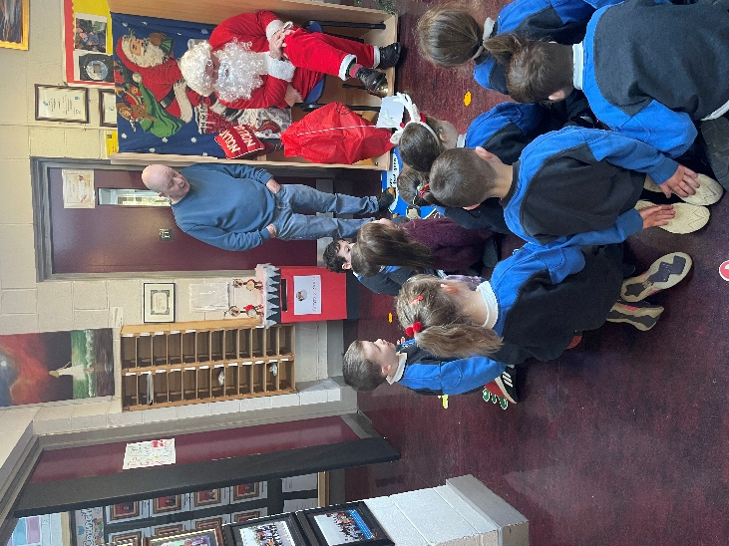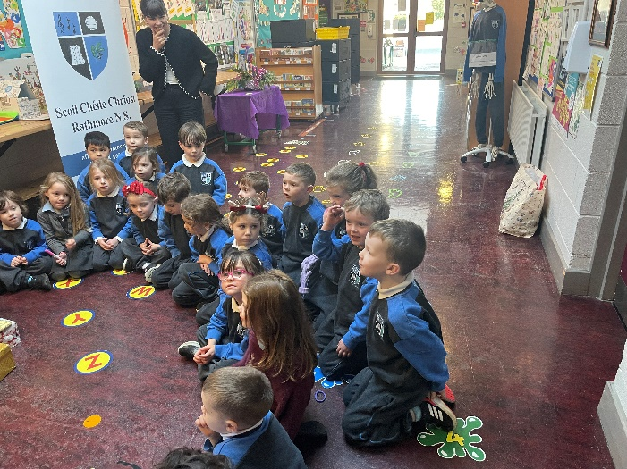
Ms. Flynn’s Junior Infants visit Santa.
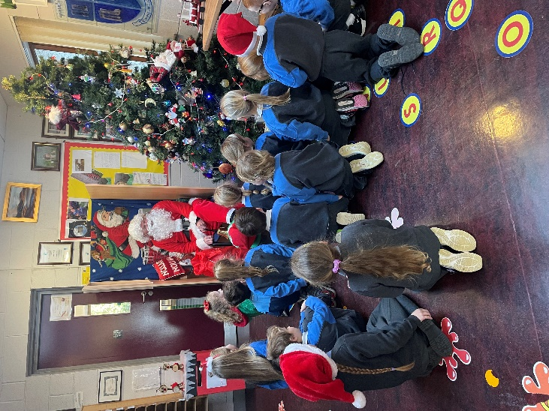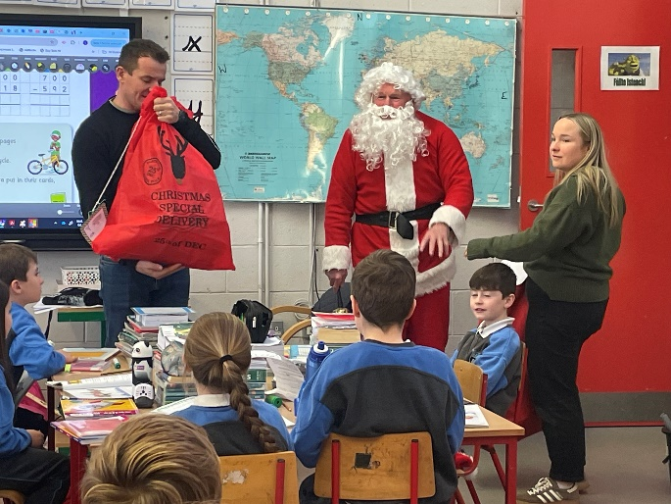
Ms. Broe’s Senior Infants visit Santa Surprise visit for Mr. Walsh’s Third Class
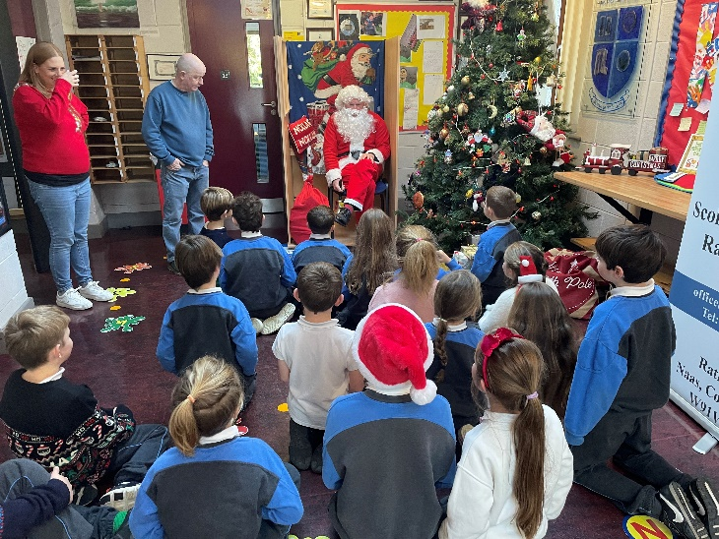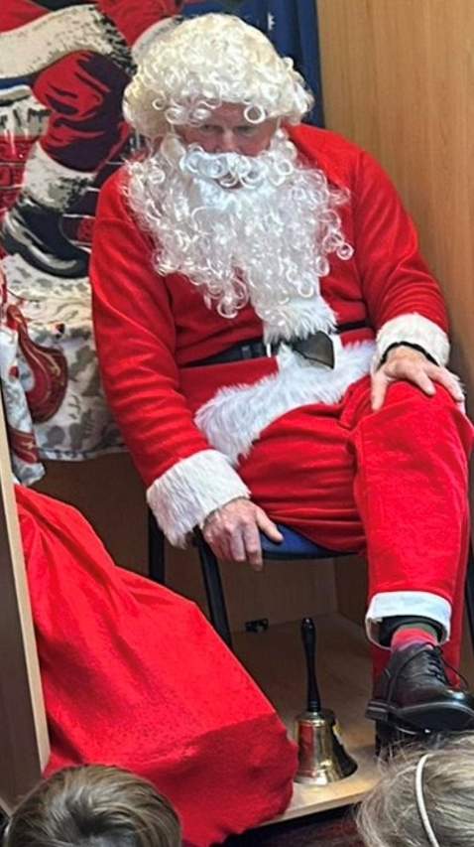
Ms. Kenny’s Second-Class visit Santa Santa gave great tips for making
it onto the nice list!

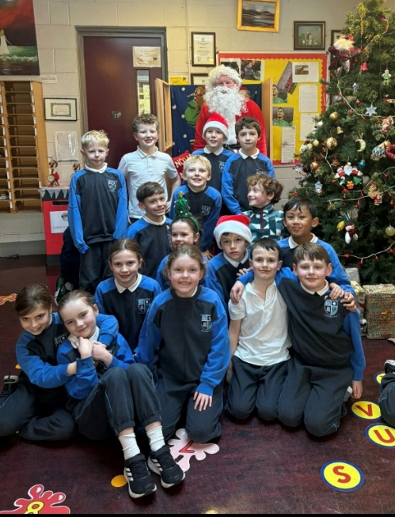
Ms. Smith’s Second Class enjoyed their visit with Santa.

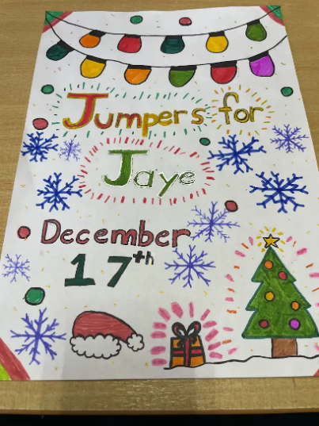
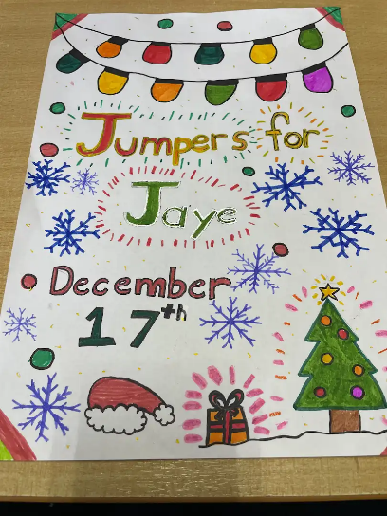
Jumpers for Jaye
On Wednesday, 17th December, our school proudly wore Christmas jumpers in support of Jessica Gibson in 5th Class. The day was organised by Mr Collier’s 5th and 6th Class, who did tremendous work preparing for the event by creating posters and spreading the word throughout the school. The colourful jumpers brought great cheer, and it was wonderful to see the whole school community coming together to show their support with a total of 1,490 euro collected in the school.
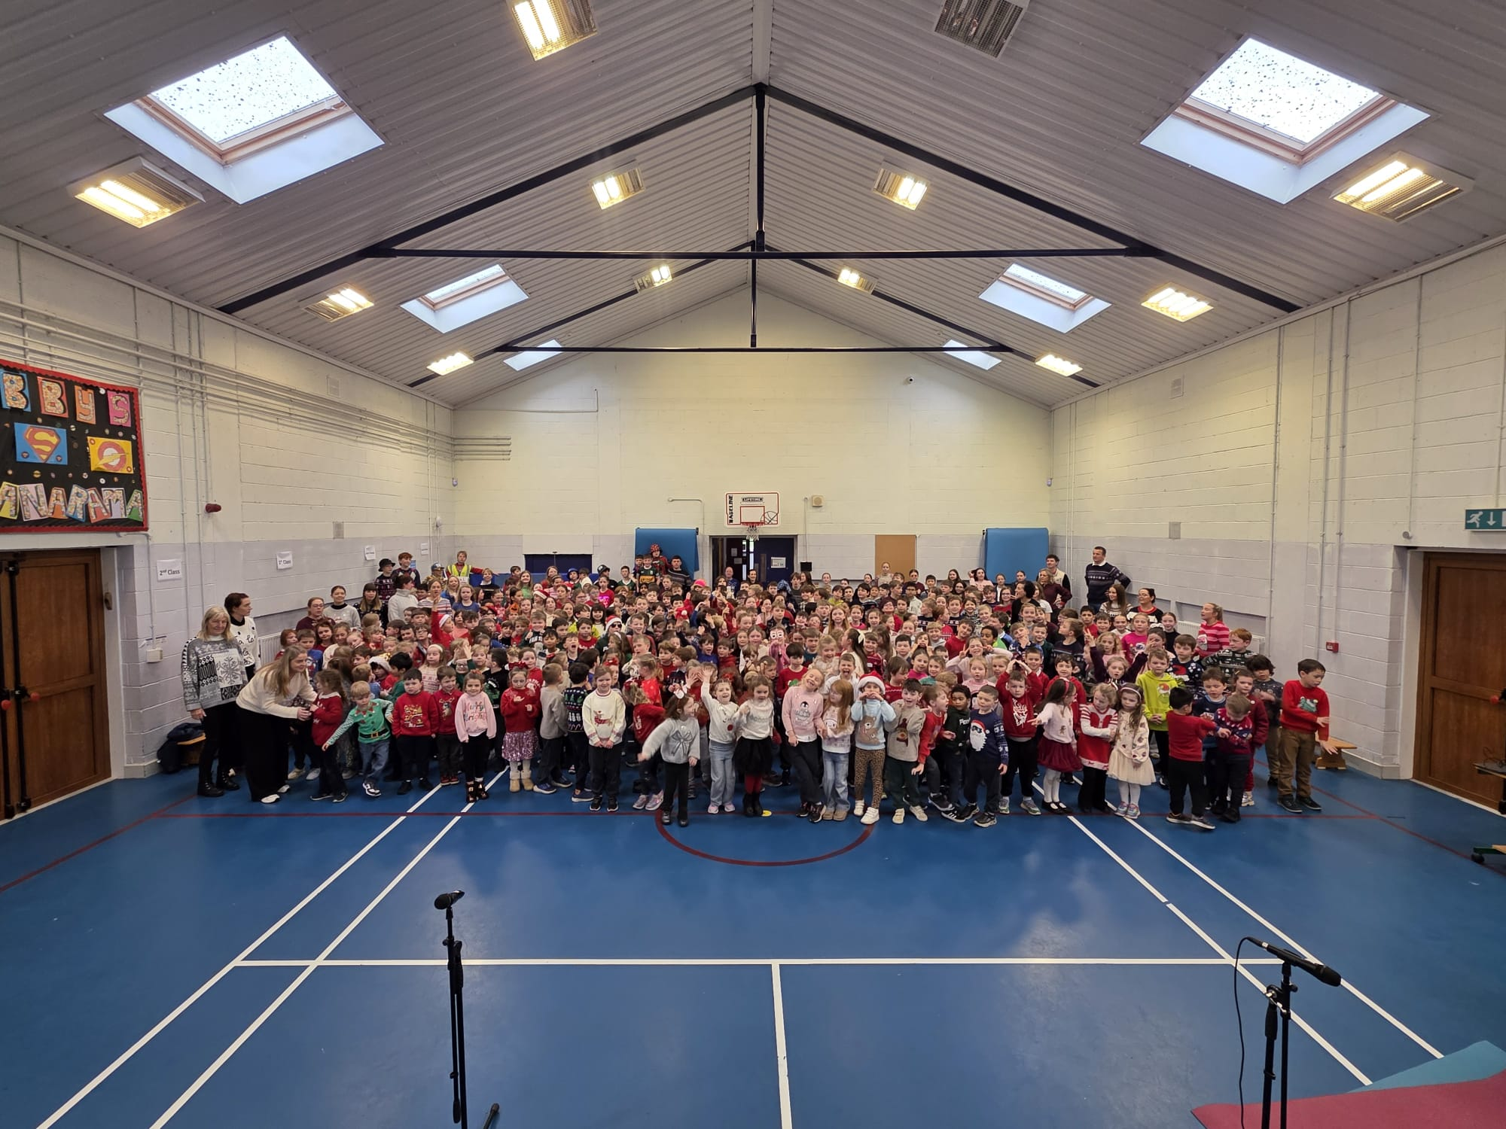

Whole School wearing Christmas jumpers for “Jumpers for Jaye.”

Here is a message from Jessica’s class:
Our friend Jessica has been diagnosed with Alveolar Rhabdomyosarcoma – a rare form of cancer.
As part of her treatment, Jaye has joined a clinical trial to give her the best possible support in the battle ahead. At the end of December, she will travel to Manchester for 8 weeks to undergo a special type of radiotherapy called proton beam therapy.
To help Jessica, we are organising a fundraiser called ‘Jumpers for Jaye,’ taking place in school this Wednesday, 17th December. It is our usual Christmas Jumper Day, but this year all donations will go directly to support Jaye and her family.
Over €1,490 euro was collected in the school and money was still coming in when writing this, thanks to everyone’s generosity.



Christmas Carol Service
Mr. Collier’s 5th and 6th Class joined the Eadestown Church Choir and Kilteel Church Choir in Eadestown Church for a Carol Service of Hope, Peace, and Love on Wednesday, 17th December at 7:30 pm.
The children sang four beautiful Christmas-themed songs and hymns. For the finale, our younger pupils dressed as shepherds and angels and joined in a heartwarming rendition of “Away in a Manger.”
Every donation received, no matter the size, went directly towards supporting Jaye’s treatment, care, and day-to-day expenses. We hugely appreciate the generosity and kindness shown by everyone who contributed. €2,185 was raised on the night, a reflection on the compassion and generosity of the community and an expression of heartfelt support and love for Jaye and her family.
A special word of thanks to the Eadestown and Kilteel Church Choirs for their wonderful music, to Siobhán Fay for her coordination, and to Ms. Gleeson and Mr. Collier for preparing the children so beautifully. We also want to acknowledge the parents for their support and encouragement in making this event such a memorable and meaningful occasion.

SVP Food Appeal
A huge thank you to Ms. Behan and our Student Council for their help in organising and promoting the SVP Food Appeal, and to all the families who donated so generously. Your kindness and support will make a meaningful difference to those in need.

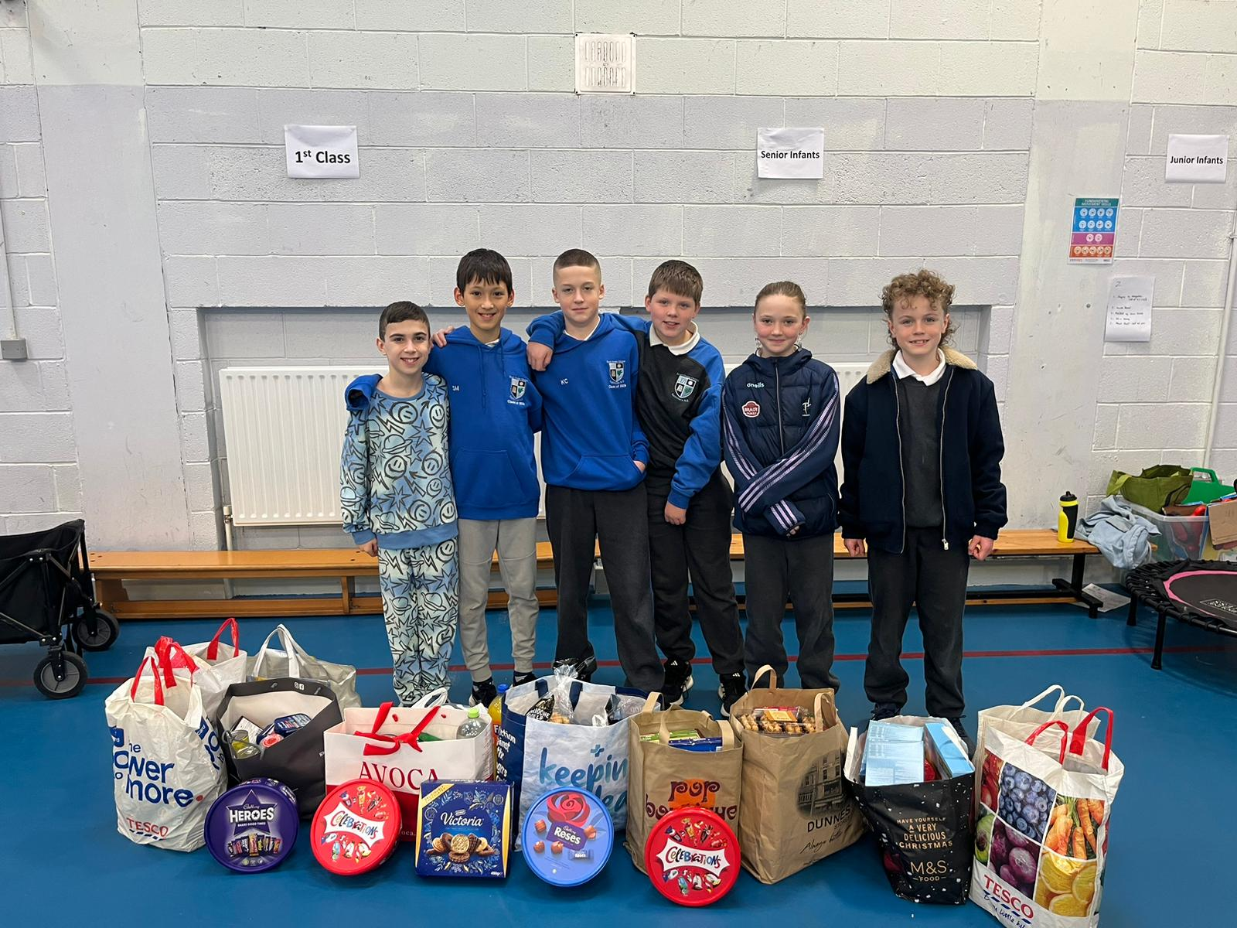
Some members of the Student Council who organised the Vincent de Paul Food Drive.

Junior Infants Enrolment 2026/27 School Year

Please note that we have now published our Annual School Admission Notice in respect of admissions to Junior Infants Classes for the 2026/2027 school year. It is important to note the dates which are applicable for admission to Junior Infants Classes for the 2026/2027 school year.
The school will begin accepting completed Application Forms for places in Junior Infants 2026/27 on 5th January 2026 and will close on 6th February 2026.
Failure to accept an offer, or to return a completed Application Form to the school, within the prescribed period outlined on the Admission Notice may result in the offer being withdrawn. Please spread the word among our school community that enrolment for Junior Infants classes 2026/27 opens from 5th January.
Please contact Martina, our School Secretary in the school office on TEL: 045-862145 or by email on office@rathmorens.ie for an Application Form or it can also be downloaded from the school website.
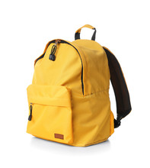

Child Safeguarding Statement– Board of Management Annual Review

The Board of Management of Scoil Chéile Chríost Rathmore N.S has adopted these procedures as school policy.
Please note that the Designated Liaison Person (DLP) in place for dealing with child protection concerns is the school Principal, Caitríona Lancaster and the Deputy Designated Liaison Person (DDLP) is the Deputy Principal, Shane Walsh.
The Board of Management has recently completed an annual review of our Child Safeguarding Statement and Risk Assessment. A copy of our school’s Child Safeguarding Statement and Risk Assessment are on display in the school reception area and parents/guardians are welcome to read a hard copy of the documents in the school office or read the documents on the school website.

Parents Association

Our Parents Association have been busy this month ensuring that Rathmore Hall was decorated and ready to host the annual Christmas Fair on Friday 12th December. There were teas/coffees and a selection of home baking available to purchase.
A big Thank You to all the parents who donated home baking to the Tea/Coffee Stall and those of you who generously donated a range of prizes for the Christmas Raffle. The raffle was very well supported with tickets sold on the day and through the link on Aladdin.
The draw took place in the school PE Hall on Thursday 18th December at 11pm. Well done to everyone who won prizes! The funds raised go towards funding activities and providing resources for your children attending the school.

Nasal Flu Vaccines.

A team from the HSE came to the school for three days during November and December and administered the nasal flu vaccine to all children from Junior Infants to Sixth Class.



School garden:
A big thank you to our wonderful garden volunteers for all their hard work in keeping our school garden looking so beautiful and festive. Their dedication and care are hugely appreciated. Many of our current garden volunteers have children in sixth class and will be finishing their time with us in June. We would love to welcome fresh faces to help continue this great work. The Green Schools Committee would be delighted to have some extra hands, and this is a fantastic opportunity to learn the ropes by shadowing our experienced volunteers from January to June. If anyone is interested in getting involved, please let Martina know.

Thank you from the Green Schools committee.

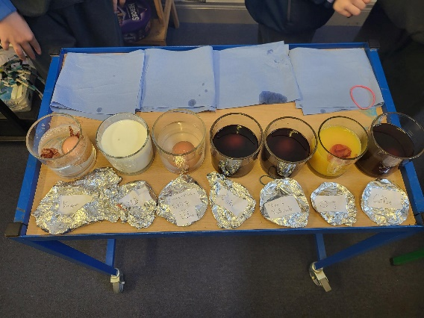

Spotlight on STEM: Pupil Voice
This month in Ms. Malone’s 5th class, we did an Eggshell Drinks Experiment as part of our Science/STEM learning. We were investigating the effects that different drinks have on our teeth. We used tea, coffee, juice, Coke, milk and vinegar. A few of us hard-boiled eggs at home because eggshells are similar to the enamel on our teeth. We put one egg in water as our control egg and poured the same amount of liquid over each egg to make it a fair test. We kept them covered with tin foil and observed them for 48 hours. After two days, we were shocked at how discoloured the eggs in coffee, tea and Coke became, and the shell in vinegar completely fell off! The vinegar one smelled absolutely disgusting and the milk one was starting to go off. We recorded our results in our copy, and we all agreed it’s important to brush our teeth and be careful about what we drink and eat so that we can keep our teeth healthy. 5th Class, Room 11

Swimming
Swimming for all pupils in Mr. Walsh’s 3rd Class and Ms. Kenny’s and Ms. Smyth’s 2nd Classes begins on Wednesday January 7th in K-Leisure in Naas. Permissions, and payment details are available to parents on Aladdin.


Dates for your Diary
Christmas Holidays: Start on Friday 19th December at 12.30pm and school re-opens on Monday 5th January 2026.
Enrolments open for Junior Infants, Monday January 5th 2026.
Children and teachers will join in on the parish webcam for mass for celebration of the Feast of the Epiphany on Tuesday 6th January 2026.
Swimming begins on Wednesday the 7th of January for 2nd and 3rd Classes in K Leisure.
Sixth Class Retreat. Students will travel to Dominican Retreat House, Tallaght, Dublin: Thursday 22nd January during the school day. Details available on Aladdin in January.
Junior Infant Parent/Teacher Meetings after School on Wednesday 21st and Thursday 22nd January 2026. Details for booking will be on Aladdin in January after Christmas holidays.
St. Brigid’s Day Bank Holiday: School closed on Monday 2nd February 2026.
Hearing Tests for Junior Infants, Thursday the 12th of February 2026.
Mid-Term break: School closed on Thursday 19th and Friday 20th February 2026.
NOTE: Additional School Closure Primary Curriculum Framework Whole School CPD: Wednesday 4th March 2026
Confirmation in Eadestown, Church of the Immaculate Conception on Friday, March 13th 2026.
St. Patrick’s Day: School closed on Monday 16th & Tuesday 17th March 2026.
Easter Break: Starts at 12.30 pm on Friday 27th March 2026 and school re-opens Monday, April 13th, 2026.

Christmas Holidays

School Finishing Times – Friday, 19th December
School will close at 12:30 pm on Friday, 19th December for the Christmas Holidays.
Please see the staggered collection times below:
Time | Collection Group
12:00 pm | School buses depart
12:10 pm | Funbugs Collection
12:15 pm | Junior & Senior Infants and their siblings
12:20 pm | 1st & 2nd Classes and their siblings
12:25 pm | Remaining pupils – 4th to 6th Classes
Important Note:
School buses will leave at 12:00 pm as they need to collect secondary school students in Naas at 12:30 pm.
Please ensure children collected by car are picked up promptly at their allocated time to avoid traffic congestion in the car park.
School will reopen for all pupils on Monday, 5th January 2026

Have a wonderful Christmas and a Happy New Year from the staff of Rathmore N.S.!

