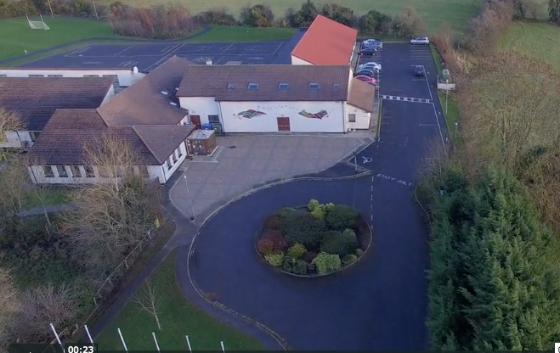
Scoil Cheile Chriost Rathmore N. S.
Rathmore, Naas, Co. Kildare. W91 VK46
Telephone: 045 862145
Email: office@rathmorens.ie
Web: www.rathmorens.ie
Registered Charity Number: 20124151
Principal: Ms. Caitríona Lancaster
Deputy Principal: Mr. Shane Walsh

Form of Enquiry 2026/2027

Name of Child: _________________________________________________________________________
Date of Birth: _______________________________________ Proposed Year of Entry: _______________
Gender: _______________________________
Address: ______________________________________________________________________________
_______________________________________________________________________________
Nationality: _________________________ Home Telephone Number: ____________________________
Mother’s Name: ______________________Email Address: ______________________________________
Mother’s Mobile No: _____________________________ Work No: ______________________________
Father’s Name: _______________________Email Address: _______________________________________
Father’s Mobile No: ______________________________Work No: ________________________________

Submission of completed Form of Enquiry does not guarantee Admission.
We understand that this registration places the applicant pupil on a list of those requiring enrolment application for the year stated. I/We understand that this registration does not offer any preferment to the applicant pupil and does not guarantee any place for him/her either for the year requested or for any other year.

Signed: ______________________________________________________________ Date: _____________
Signature of Parent/Guardian

