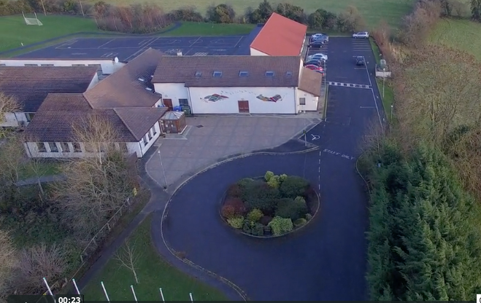
Scoil Chéile Chríost Rathmore NS
Rathmore, Naas, Co. Kildare. W91 VK46
Telephone: 045 862145
Roll Number: 01821v
Email: office@rathmorens.ie
Web: www.rathmorens.ie
Principal: Ms. Lucy Travers
Deputy Principal: Ms. Caitríona Lancaster

ANNUAL ADMISSION NOTICE
In respect of Admissions to the 2024/2025 School Year
Admission Policy and Application Form

A copy of the school’s Admission Policy and the Application Form for Admission for the 2024/2025 School year is available as follows: –
To download at: www.rathmorens.ie or on request by emailing office@rathmorens.ie or writing to: Scoil Chéile Chríost Rathmore N.S., Rathmore, Naas, Co. Kildare. W91 VK46.
This Admissions Policy should be read in conjunction with all School Policies (available on the School Website)

PART 1 - Admissions to the 2024/2025 School Year
Application and Decision Dates for admission to 2024/2025.
The following are the dates applicable for admission to Junior Infants.
The school will commence accepting applications for admission on 08/01/2024 | 08/01/2024
The school shall cease accepting applications for admission on 19/01/2024 | 19/01/2024
The date by which applicants will be notified of the decision on their application is 29/01/2024 | 29/01/2024
The period within which applicants must confirm acceptance of an offer of admission is January 29th to February 6th 2024 | 29/01/2024 to 06/02/2024
The date within which applicants must furnish a completed Enrolment Form | 19/02/2024
*Failure to accept an offer within the prescribed period above may result in the offer being withdrawn
Note: the school will consider and issue decisions on late applications in accordance with the school’s admission policy.

Number of places being made available in 2024/2025.

The number of places being made available in Junior Infants | 40

