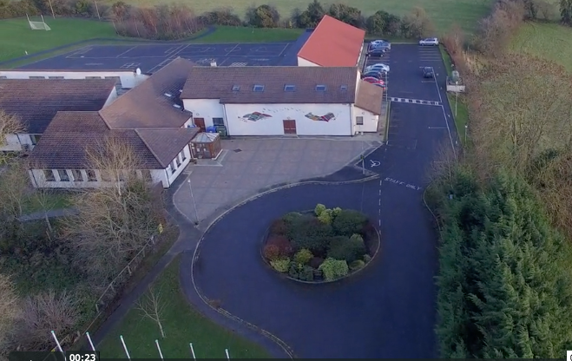
Scoil Chéile Chríost Rathmore NS
Rathmore, Naas, Co. Kildare. W91 VK46
Telephone: 045 862145
Roll Number: 01821v
Email: office@rathmorens.ie
Web: www.rathmorens.ie
Principal: Ms. Lucy Travers
Deputy Principal: Ms. Caitriona Lancaster

ANNUAL ADMISSION NOTICE
In respect of admissions to the 2022/2023 School Year
Admission Policy and Application Form

A copy of the school’s Admission Policy and the Application Form for Admission for the 2022/2023 School year is available as follows: –
To download at: www.rathmorens.ie or on request by emailing office@rathmorens.ie or writing to: Scoil Chéile Chríost Rathmore N.S., Rathmore, Naas, Co. Kildare. W91 VK46.
This Admissions Policy should be read in conjunction with all School Policies available on the school website.
PART 1 - Admissions to the 2022/2023 School Year
Application and Decision Dates for admission to 2022/2023.
The following are the dates applicable for admission to Junior Infants.

The school will commence accepting applications for admission on 06/01/2022 | 06/01/2022
The school shall cease accepting applications for admission on 07/02/2022 | 07/02/2022
The date by which applicants will be notified of the decision on their application is 18/02/2022 | 18/02/2022
The period within which applicants must confirm acceptance of an offer of admission is February18th 2022 to March 01st 2022 | 18/02/2022 to 01/03/2022
The date within which applicants must furnish a completed Enrolment Form & all required documents | 10/03/2022

*Failure to accept an offer within the prescribed period above may result in the offer being withdrawn

Note: the school will consider and issue decisions on late applications in accordance with the school’s admission policy.

Number of places being made available in 2022/2023.

The number of places being made available in Junior Infants | 38

