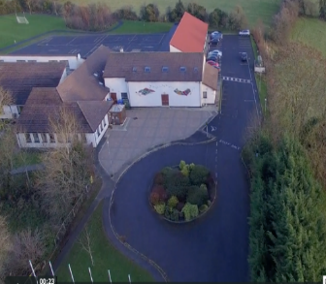
Scoil Chéile Chríost Rathmore NS
Rathmore, Naas, Co. Kildare. W91 VK46
Telephone: 045 862145
Roll Number: 01821v
Email: office@rathmorens.ie
Web: www.rathmorens.ie
Registered Charity Number: 20124151
Principal: Ms. Lucy Travers
Deputy Principal: Ms. Caitriona Lancaster

Dear Parents/Guardians
As Principal of Scoil Cheile Chríost Rathmore N.S., it is my pleasure to welcome you to our school website and I thank you for taking the time to visit. I hope that you will find some useful information about our school, and it will give you an insight into the wealth of experiences we offer to pupils. You are most welcome to make an appointment to visit us in person, as our door is always open.
Scoil Chéile Chríost Rathmore N.S. is a co-educational vertical primary school, educating girls and boys from Junior Infants to Sixth Class and is situated in a beautiful part of Co. Kildare which is surrounded by nature. We have a Catholic ethos and operate under the patronage of the Dublin Archdiocese. We strive to provide a caring, inclusive, happy and secure atmosphere to cater for the intellectual, spiritual, physical, moral and cultural needs of our pupils.
We aim to nurture each child’s overall development and well-being during their time with us through participation in a range of learning experiences to develop the concepts, skills and dispositions that are necessary for life-long learning, in a very attractive school environment that is spacious, well-resourced and maintained to a very high standard.
We have a very dedicated and committed teaching and ancillary staff team. They work diligently to ensure that each child flourishes and achieves to their full potential and are happy, confident learners and communicators. We seek to develop a strong sense of pride and belonging in our school and to celebrate the successes of the whole school community.
Our Board of Management and Parents’ Association are hard-working and always place the best interests of the children and the school at the centre of every decision that they make. We encourage the involvement of parents through regular home-school contact and communications and through their involvement in the Scoil Chéile Chríost Rathmore N.S. Parents Association. We are proud to have achieved seven Green Flags as part of the Green Schools environmental management and award programme. We have also been awarded Discover Primary Science Awards, a Digital Schools of Distinction award for digital learning, a Global Citizenship Award for raising awareness to make the world a fairer and better place for all and we are working towards the renewal of our Active Schools Flag which places an emphasis on encouraging the children to increase their daily physical activity to support their well-being. We are also taking part in the Creative Schools Initiative which aims to develop the creative potential of every child.
You are welcome to contact the school directly by telephone or email if you require any further information or clarification.
We look forward to your continued support and collaboration into the future.
Le gach dea-ghuí
Lucy Travers
Principal Teacher

