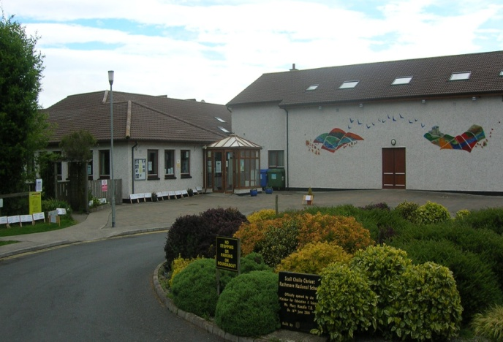
Scoil Chéile Chríost Rathmore NS
Rathmore, Naas, Co. Kildare
Telephone: 045 862145
Fax: 045 862952
Email: office@rathmorens.ie
Web: www.rathmorens.ie
Principal: Mrs. Lucy Travers
Deputy Principal: Ms. Caitriona Lancaster
Assessment and Recording Policy

Introduction:
This policy was revised during 2020-2021.
Policy Rationale:
The core of the policy is that all children should experience success at school. This policy endeavours to identify at the earliest possible opportunity, children who may have learning difficulties and put in place a school response to their needs. An effective assessment policy is central to this core objective.
Relationship to School Ethos:
The school adopts a holistic approach to the education and development of each child, the enhancement of teaching processes. An effective Assessment policy identifies early interventions that need to be put in place to ensure that enhancement, increased confidence and raised self-esteem is achieved.
Aims and Objectives:
The primary aims/objectives of the policy are;
- To facilitate improved pupil learning
- To create a procedure for monitoring achievement
- To track learning processes which assist the long and short term planning of teachers
- To co-ordinate assessment procedures on a school basis involving parents and pupils in managing strengths and weaknesses

Principles
- Careful thought is given to the purpose of assessment, adopting a wide range of methods to reflect the whole Curriculum and learning opportunities. The main purpose of assessment must be to facilitate progress in a pupil's learning.
- Assessment is an integral part of the teaching and learning process, a valuable formative tool.
- The range of opportunities for carrying out continuous assessment is increased by good classroom organization, which encourages children to work independently while the teacher is concentrating on a small group.
- The outcomes of assessment modify our teaching methods, provide feedback on the Curriculum as well as indicate pupil progress.
- We recognize the potential for assessment in developing a positive self-image in the pupil from positive and constructive feedback and the feeling of success, which encourages further study.
- Results of assessment are reported in a way useful for pupils, teachers, parents and other interested parties.
- Assessment of behaviour and performance gradually builds up into a profile for each pupil over his school career. This is a working document for the use of teaching staff only.

Policy Content:
Our school embraces N.E.P.S. Continuum of Support and we follow the D.E.S. Guidelines for the New Model of Support (2017). This policy is geared towards using assessment to inform planning and identify the needs of all pupils, including the exceptionally gifted so that adequate strategies are put in place early enough to facilitate remediation. These strategies may include pupil self-assessment, pupil profiling, two-way communication between parents and teachers, modification of teacher programmes (differentiation in the classroom) and School Support Plans.
Standardised Testing:
All classes from First Class are given standardised tests every year.We use Sigma-T Maths tests and Drumcondra Reading tests. These tests are usually administered by the class teacher, during a designated week in May. We introduced the Drumcondra Spelling Test in 2018. This is administered by class/ S.E.N. teachers in Term 3, usually April. We also administer the Micra-T in the autumn term to first class only. All results are recorded on Aladdin by each individual teacher with a hard copy held by the S.E.N. team. The SET analyse the results in June for allocation of resources to pupils in September. Results are also included in the children’s end of year reports for parents.
Diagnostic Assessment:
Diagnostic tests are administered by S.E.T. following referral/concerns raised by the class teachers in consultation with parents/guardians. The administration of such tests is in keeping with the approach recommended by N.E.P.S. Continuum of Support where a staged approach is used by the individual class teachers before recourse to diagnostic testing /psychological assessment. These tests provide detailed information to allow for implementation of S.M.A.R.T. targets and an individualised plan for intervention (S.S.F.). Parents are provided with test results and if a psychological assessment is warranted, parental permission is sought and a consent form is completed. The Principal will facilitate such an assessment happening.
The diagnostic tests available in the school include;
- Neale Analysis
- Jackson – Get Reading Right
- Dyslexia Portfolio
- Schonell Reading and Spelling.
- Quest (after analysis of Quest Screening Tests in First Class)
- YARC; “York Assessment of Reading Comprehension” including Early Reading Assessment
- Drumcondra Spelling Test (2nd to 6th classes)
- Drumcondra Early Numeracy Test

Irish Exemptions

Circular 0052/2019 (EXEMPTIONS FROM THE STUDY OF IRISH: REVISING CIRCULAR 12/96) allows a principal to grant an Irish exemption in exceptional circumstances (section 2) without the need for an educational assessment.
As stated in Section 2, circular 0052/2019, where literacy attainment scores are used as criteria:
“In the case of pupils with significant and sustained learning difficulties, the criteria for exemption include a literacy attainment score, in either Word Reading, Reading Comprehension, or Spelling at/below the 10th percentile”.
If the need arises, our school will use “The Drumcondra Spelling Test” and/or YARC to determine if a child meets the above criteria. Both tests are approved by the D.E.S. for this purpose.
The decision to exempt a pupil from the study of Irish is an important decision that has implications for his/her access to the curriculum and his/her future learning. The decision to grant an exemption from the study of Irish is made by the principal teacher, but it must be made following detailed discussion with the pupil’s parent(s)/guardian(s), the class teacher, S.E.N. teacher and the pupil.

Screening
The screening tests used to identify learning strengths and weaknesses in the school are;
- Middle Infant Screening Test (MIST): Second term of senior infants.
- Quest Reading and Maths: Second term of first class.
- NEW Non-Reading Intelligence Test (NNRIT): Second term of third class.

These tests are administered on a class basis. Screening is used by the school to initiate the staged approach to intervention as per our S.E.N. Policy. The “Forward Together” programme will be undertaken if any child meets the criteria after the M.I.S.T. screening test. The Quest diagnostic tests will be administered if required after the Quest screening test.
Professional Assessments
If stages 1 and 2 fail to deliver adequate intervention, the class teacher/S.E.T. will contact the parents to discuss the need for a suitable professional assessment for their child: educational, O.T., Speech and Language, Multi-disciplinary assessment. An assessment will determine the subsequent level of intervention.

Informal Assessments
We use the Continuum of Assessment methods as outlined in “Assessment in the Primary School Curriculum: Guidelines for Schools”.
Teachers are encouraged to use a wide range of assessment methodologies such as:
• Teacher observations
• Teacher designed tasks
• Simple projects
• Responses the child makes to question and answer situations
• Child participation
• Interaction and reaction of the child
These informal assessments are at the discretion of individual teachers. Records of teacher-designed tests are kept by the individual teachers and communicated to parents at the Parent-teacher meeting and the school report issued at the end of the school year. Each teacher has discretion as to the format, administration and frequency of in-class testing. Class teachers keep an “Assessment” folder detailing results of tests given and outlining progress throughout the year.

Teachers may use the Drumcondra Profiles (3rd to 6th) to assist them in making judgements about their pupils’ achievement of key curriculum outcomes in English.

Recording:
Each pupil has a file which is stored on “Aladdin”. All standardised test results are also stored in a cabinet in the SEN room. This file is accessible to the class teacher/ SEN teacher/Principal. All pupils have a pupil profile which includes class tests and samples of work. The class teacher holds these in a secure filing cabinet and they are passed on to next class teacher every new school year. Procedures are in place to manage sensitive data (see Data Protection Policy).
Success Criteria:
This policy is considered successful if;
- Early identification and intervention are achieved
- Clarity is achieved regarding procedures involved in a staged approach incorporating N.E.P.S. Continuum of Support.
- Procedures are clear, with roles and responsibilities defined
- S.E.T. have clearly defined roles and objectives
- There is efficient transfer of information between teachers

Roles and Responsibilities:
Mainstream, Special Education Teachers and the Principal assume shared responsibility. It is the responsibility of the class teacher to set in train staged interventions at class level, putting a Classroom Support Plan in place if deemed necessary. At Stage 2, the responsibilities are shared with the Special Education Team and a School Support Plan is opened. The Principal assumes a primary role at Stage 3 when a Psychological Assessment may be required. Parents have a role at all stages and the lines of communication must be always kept open.
Implementation
This policy supersedes the previous policy and is effective from January 2021
Ratification & Communication:
This policy was ratified by the Board of Management in February 2021 and communicated to parents thereafter.
Review Timetable:
This policy will be reviewed every three years (or as circumstances may warrant) and amended as necessary by means of a whole school collaborative process.
References:
DES Circular 02/05
DES Guidelines for New Model of Support 2017
Working Together to make a Difference for Children – NEPS
www.sess.ie

This policy was ratified by the Board of Management in February 2021.
Signed: ______________________________________________ Date: _______________
Chairperson, Board of Management

