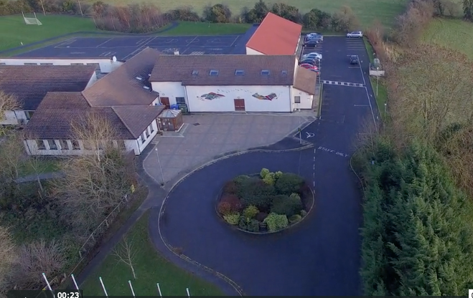
Scoil Chéile Chríost Rathmore NS
Rathmore, Naas, Co. Kildare. W91 VK46
Telephone: 045 862145
Roll Number: 01821v
Email: office@rathmorens.ie
Web: www.rathmorens.ie
Principal: Ms. Lucy Travers
Deputy Principal: Ms. Caitriona Lancaster

Application for Admission to Scoil Chéile Chríost Rathmore N.S.
School Year 2021 – 2022
Please note that this form is for application purposes only. The information provided will be used to allocate Junior Infant places in accordance with the School’s Admission Policy. Please complete all sections of the form.
General Information on Child

First Name |  | Surname
PPS Number | Date of Birth |  | Gender
Address

Eircode
Sibling(s) in school: Yes No

If yes name siblings:

Child’s Current School/Preschool:

Current Class: Class Application School Year Application
General Information on Parent(s)/Guardian(s)
Parent/Guardian Name:  Date: |  | Parent/Guardian Name:  Date:
Email Address: |  | Email Address:
Address (if different from child’s)  Eircode |  | Address (if different from child’s)  Eircode
Mobile Number |  | Mobile No
This Application MUST be accompanied by your child’s Original Birth Certificate, Baptismal Certificate (if applicable) and Household Utility Bill. The school will make a copy of the document(s) submitted and will return all of the original documents.
Declaration
I/we being the parent/guardian of the applicant do hereby confirm that the above information is true and accurate and I/we consent to its use as described.
Parent(s)/Guardian(s) Signature | Parent(s)/Guardian(s) Signature
Office Use Only
Date Application Received

Data Privacy Statement
The information provided on this form will be used by Scoil Chéile Chríost Rathmore N.S. to apply the selection criteria for enrolment in Junior Infants, and to allocate school places in accordance with the School’s Admission Policy.
Where a pupil is admitted to the school, the information will be retained on the pupil’s file.
On acceptance of an offer of admission, this information will be entered in the School Administration System (Aladdin Schools) and will be uploaded to the Primary Online Database. The Primary Online Database (POD) is a nationwide individualised database of primary school pupils, hosted by the Department of Education and Skills.
In the event of oversubscription, a waiting list of students whose applications for admission to Scoil Chéile Chríost Rathmore N.S. were unsuccessful due to the school being oversubscribed will be compiled, and will remain valid for the school year in which admission is being sought
Where a child’s name is placed on a waiting list, and the child is not admitted to the school, the information provided on this form will be retained for the duration of the school year and will be securely destroyed thereafter.
Section 66(6) of the Education (Admission to Schools) Act 2018 allows for the sharing of certain information between schools in order to facilitate the efficient admission of students.
The information which may be provided to a patron or another Board of Management for this purpose may include all or any of the following:
(i) the date on which an application for admission was received by the school;
(ii) the date on which an offer of admission was made by the school;
(iii) the date on which an offer of admission was accepted by an applicant;
(iv) a student’s personal details including his or her name, address, date of birth and personal public service number (within the meaning of section 262 of the Social Welfare Consolidation Act 2005).

