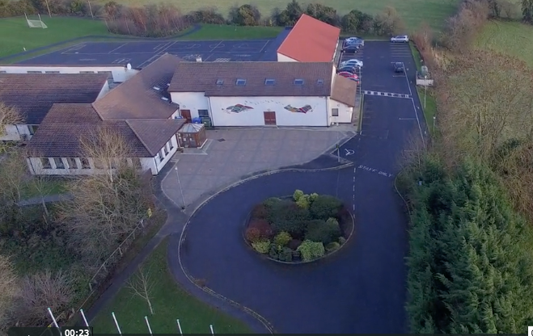
Scoil Chéile Chríost Rathmore NS
Rathmore, Naas, Co. Kildare. W91 VK46
Telephone: 045 862145
Roll Number: 01821v
Email: office@rathmorens.ie
Web: www.rathmorens.ie
Principal: Ms. Lucy Travers
Deputy Principal: Ms. Caitriona Lancaster

ANNUAL ADMISSION NOTICE
In respect of admissions to the 2021/2022 School Year

Admission Policy and Application Form

A copy of the school’s Admission Policy and the Application Form for Admission for the 2021/2022 School year is available as follows: –
To download at: www.rathmorens.ie or on request by emailing office@rathmorens.ie or writing to: Scoil Chéile Chríost Rathmore N.S., Rathmore, Naas, Co. Kildare. W91 VK46.

PART 1 - Admissions to the 2021/2022 School Year
Application and Decision Dates for admission to 2021/2022.
The following are the dates applicable for admission to Junior Infants.

The school will commence accepting applications for admission on | 06/01/2021
The school shall cease accepting applications for admission on | 05/02/2021
The date by which applicants will be notified of the decision on their application is | 15/02/2021
The period within which applicants must confirm acceptance of an offer of admission is | 15/02/2021 to 22/02/2021
The period which applicants must furnish a completed Enrolment Form | 5/03/2021
*Failure to accept an offer within the prescribed period above may result in the offer being withdrawn

Note: the school will consider and issue decisions on late applications in accordance with the school’s admission policy.

Number of places being made available in 2021/2022.
The number of places being made available in Junior Infants | 38

