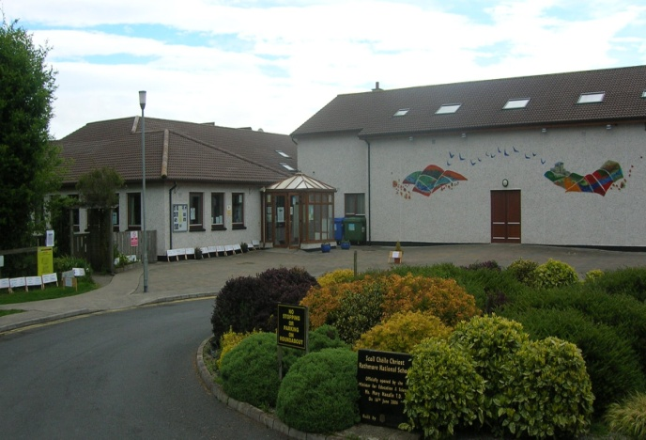
Scoil Chéile Chríost Rathmore NS
Rathmore, Naas, Co. Kildare
Telephone: 045 862145
Email: office@rathmorens.ie
Web: www.rathmorens.ie
Principal: Ms. Lucy Travers
Deputy Principal: Ms. Caitriona Lancaster
Healthy Eating Policy
Introductory Statement.
Children’s eating habits will strongly influence his/her chances of living a healthy life-style. Our Healthy Eating Policy was originally formulated back in 2010 by the parents and staff of Scoil Chéile Chríost. This reviewed policy was completed in June 2017 in consultation with the staff of Scoil Chéile Chríost, Hilary Dowling (A Health and Nutrition Consultant), the Parents’ Association, and the Board of Management. It was intended to encourage children to get into good dietary habits. Children grow and develop at a fast rate. Therefore, they need a high-quality diet which contains adequate energy, proteins, vitamins, minerals and fibre. The present policy was formulated because of a review and updating of the original policy. A copy of this policy will be kept in the school office and may also be viewed and downloaded from the school web site www.rathmorens.ie
Rationale
This policy is intended as a guide to healthy and safe eating for the school. The focus of this policy is to support parents in encouraging their children to develop healthy eating habits at an early age. Knowledge of what constitutes a nutritionally balanced diet is acknowledged as being of importance for students. In support of this rationale nutrition education is a crucial element of the curriculum in Scoil Chéile Chríost.
SPHE: Primary School Curriculum:
• Strand Unit: Taking Care of my Body; Food and Nutrition (Curriculum: Junior Infants-6th Class)
• Making Choices (see Teacher Guidelines pp11-13)
Science: Primary School Curriculum:
• Strand: Living Things; Strand Unit: Myself: Human life Processes (Curriculum: Junior Infants -6th class) (see Teacher Guidelines p.10-11)

Mission Statement.
Scoil Chéile Chriost, through these guidelines, aims to help all those involved in our school community, children, staff and parents, to develop positive attitudes to eating and healthy living. We wish to promote ‘the personal development and well-being of the child and to provide a foundation for healthy living in all its aspects’. (SPHE Guidelines)
- To help achieve this, our guidelines will reflect good eating habits. These should be established at an early age as children have a right to learn about different foods so that they may make informed choices throughout their life.
- The purpose of making healthy food choices enables children to attain their optimum growth, development and health potential.
- Recent research (Department of Health and Children) has highlighted disturbing trends, including an increase in childhood obesity and diabetes so therefore our policy and guidelines are both timely and critical for the health and development of children.
- Through a whole school approach and within the context of SPHE the children, parents and staff will learn about nutrition, healthy eating and healthy living.
- Our aim is that the healthy eating guidelines will serve to enable the children to develop an understanding of healthy living, and an ability to implement healthy behaviour and willingness to participate in activities that promote and sustain health. This includes physical activity.
- We feel that, in developing the policy, parents, children, teachers, school staff and the BOM should be involved in a collaborative way. We also hope to review these guidelines every two years unless the stakeholders agree a review is not necessary.
- All classes will receive a least 1 lesson on healthy eating each term.
- School staff will provide positive modelling and supportive attitudes to encourage healthy eating.
- We will also hold a Healthy Eating Awareness day/week annually. Early in first term; third week in September and should include a parents’ session.
- Parents will be supported in their role as Primary Educators by providing them with up to date information on healthy eating habits from the Dept. of Health.

Guidelines.
A healthy lunch box includes:
- At least 2 portions from the bread, cereals group.
- One portion from the meat and the meat alternatives (protein) group.
- 2/3 portions from fruits and vegetables.
- One portion from the dairy products.
- The following foods do not support a healthy lunch policy and should be excluded from your child’s lunch box:
Crisps | Chewing Gum | Sweets | Bars (including Cereal Bars)
Cakes | Lollipops | Chocolate | Fruit Winders
Crispy Buns | Capri-Suns | Fruit Corner Yogurts | Frubes
Healthy snack options (Lower in sugar and fat)
Foods from the top tier of the food pyramid should not be included in your child’s lunchbox. Fizzy drinks, chewing gum and crisps are banned.
Sometimes it can be difficult to think of alternatives to these. Here are some tasty alternatives.
- Fruit (for example; an apple or banana, handful of grapes)
- Washed, raw vegetable pieces (for example, sticks of carrot, celery, pepper and cucumber.
- Washed, raw vegetables (for example, cherry tomatoes)
- Half a tin of fruit (in its own juice)
- Plain popcorn (unsalted)
- Plain breadsticks, unsalted plain or whole-wheat crackers, crispbreads or water biscuits served with fruit or cheese.
- Plain rice cakes.
- Peanut butter, hummus
- Nuts and seeds.
- Natural or low-fat yogurt with fresh fruit (fresh, frozen or tinned in its own juice)
- Wholemeal or plain scones.
- Plain biscuits (for example, digestive biscuits, rich tea) *
- Fruit bun or mini fruit loaf. *
- A plain slice of cake. *
- A slice of carrot cake or banana bread. *
- Sugar-free jelly pots or fruit jelly.
- Pot of custard or rice pudding.
*These are best taken with meals (when they are less damaging to the teeth) and should not be taken too frequently between meals. These snacks are nutritious, but still contain some sugar, fat and salt.
Healthy choices of drink include water, milk and unsweetened natural juice. Children should use re-useable containers for safety and litter reasons. Capri-suns, frubes and cartons (fruit juices and smoothies) with straws are not permitted as they are difficult for children to open causing spillage and do not support our Healthy Eating or Green Schools litter policies. Cans and glass bottles are not permitted.

Exemptions:
- Children are allowed a small treat on Friday Only. (Suggestions include a mini-bar, biscuit or bun)
- Children will be allowed to have a treat day at end of term parties where children are permitted to bring two small treats, one for themselves and another to be shared.

Roles and Responsibilities
- Parents/guardians have the primary responsibility to provide lunches which do not include any of the prohibited foods and, if possible, to include variety.
- Children have a responsibility to eat their own lunch, and not to share or trade food or drink with others
- Parents and teachers have a responsibility to provide a good example through their own healthy eating habits.
- The whole school community- staff, parents/guardians, children –will work together to promote the progress of this policy.
- All are encouraged to discuss and provide feedback on its performance which will be reported back as appropriate to the Principal and staff
- The overall performance of the policy will be regularly monitored and evaluated by the staff and B.O.M.
Implementation
- If children bring prohibited food or drink into school they will be asked to put it away until after school as they are not permitted to eat it in school.
- Children shall be encouraged to bring healthy food to school by the parents, class teacher and principal. Parents and teachers will remind them of Healthy Eating Policy regularly. It is very difficult to implement the policy successfully if all children do not adhere to the guidelines. It is also not fair on the children who comply with our Healthy Eating Policy to see children who clearly do not obey the rules.
- This policy will be implemented from 1st September 2017.
- A copy of The New Healthy Food Pyramid will be on display in every classroom. Example appendices 1.
- Whilst teachers sometimes give children a sweet treat on occasions in recognition of work done, improvements in work or behaviour and to promote positive behaviour the giving of other rewards such as stickers, points, subject passes, homework passes is encouraged. Sweet treats will be used prudently by teachers. To promote this the Parents’ Association has offered to buy a stock of novelty pencils etc. to be used for such occasions.
Success Criteria
We will know the policy is effective by:
- Observing what children have for lunch and noticing an improvement in consumption of fruit, vegetables and other healthy foods
- The feedback from parents/guardians and other school staff
- The level of concentration and performance of children in the classroom

